# SUMMARY

Topic title: Price support real estate business website

Student name: Nguyen Duc Van

Student ID: 102210195 Class: 21TCLC_DT2

In a rapidly growing real estate market, the demand for searching and trading properties has become more common than ever. However, many buyers still struggle to correctly assess the true value of a property, while sellers often find it difficult to set a competitive and reasonable price. Contacting brokers and referring to various scattered sources makes the buying and selling process more complicated, time-consuming prone to misinformation.

From that reality, this project aims to build a price support real estate business website that helps users look up, post and search for properties based on their needs. Most importantly, it integrates a price recommendation system and future price prediction based on market data. This gives both buyers and sellers a reliable tool to make better decisions, save time and costsand improve transaction efficiency.

The website is mainly developed using JavaScript and Java. It applies machine learning to analyze data and suggest optimal pricing. The system also includes online payment integration and AI tools to check post content, such as verifying if images are appropriate for work environments.

In the introduction and Chapter 1, the project analyzes current user needs and challenges, the goals and features of the project, the target users, usage scopeand the technical background that supports the website’s development.

Chapter 2 covers business analysis, system designand database structure.

Chapter 3 presents the implementation and detailed descriptions of the features developed.

Chapter 4 evaluates the results, limitations and future development directions.

Finally, lists the references used during the project.

I sincerely look forward to receiving feedback from my teachers and friends so that the system can be continuously improved.

|  |  |
| --- | --- |
| DA NANG UNIVERSITY  **UNIVERSITY OF SCIENCE AND TECHNOLOGY**  FALCUTY………………………………………… | **THE SOCIALIST REPUBLIC OF VIETNAM**  Independence - Freedom - Happiness |

# GRADUATION PROJECT REQUIREMENTS

Student Name: …..…………….………….…….. Student ID :………………...

Class:…………… Faculty:..................................... Major:…………...........................

1. *Topic title:*

………………………………………………..…………………………………………

…………………………………………………………………………………………..

1. *Project topic :* ☐*has signed intellectual property agreement for final result*
2. *Initial figure and data:*

……………………………………..……………………………………………..……......……………………………………………………………………………………………..………………………………….…..………………………..………………………*Content of the explanations and calculations:*

…...………………………………………………………………………………………

…...………………………………………………………………………………………

…...………………………………………………………………………………………

…...………………………………………………………………………………………

…...………………………………………………………………………………………

1. *Drawings, charts (specify the types and sizes of drawings):*

…...………………………………………………………………………………………

…...………………………………………………………………………………………

…...………………………………………………………………………………………

…...………………………………………………………………………………………

|  |  |
| --- | --- |
| 1. Name of instructor: | *Content parts:* |
|  |  |
|  |  |
|  |  |

1. *Date of assignment: ……../……./201…..*
2. *Date of completion: ……../……./201…..*

|  |  |
| --- | --- |
|  | *Đà Nẵng, date month year 201* |
| **Head of Division**…………………. | **Instructor** |

# PREFACE

# ASSURRANCE

I hereby declare that:

1. The graduation project report, Topic name: Real Estate Business System, is my own research work under the direct guidance of the lecturer MSc. Do Thi Tuyet Hoa.
2. I have read, researched, translated documents and synthesized the knowledge that has made this report and ensured that it has not been copied anywhere.
3. The theories in the thesis are all used from the documents as I have referred to in the reference section in the report.

If there is any violation, I will take full responsibility.

Student Performed

Nguyen Duc Van

# TABLE OF CONTENTS

SUMMARY 3

GRADUATION PROJECT REQUIREMENTS 4

PREFACE i

ASSURRANCE ii

TABLE OF CONTENTS iii

LIST OF PICTURES vi

LIST OF TABLES ix

LIST OF SYMBOLS, ACRONYMS xi

INTRODUCTION 1

1. Purpose of implementation 1

2. Objective of the topic 1

2.1. System Target 1

2.2. Features 1

3. Scope of project 2

4. Target customers 2

5. Development technology 2

CHAPTER 1: THEORETICAL FOUNDATION 3

1.1. Overview of tools and programming languages for Machine Learning 3

1.1.1. Python 3

1.1.2. Jupyter Notebook 3

1.2. Overview of backend development 4

1.2.1. Java 4

1.2.2. Spring Boot 5

1.2.3. MVC model 5

1.2.4. MySQL 8

1.3. Overview of frontend development 9

1.3.1. React 9

1.3.2. ChakraUI 12

1.4. Overview of deployment 12

1.4.1. Amazon Web Services 12

1.4.2. Amazon Simple Storage Service 13

1.4.3. Amazon Relational Database Service 13

1.4.4. Amazon Elastic Compute Cloud 14

1.4.5. Vercel 15

1.5. Chapter conclusion 15

CHAPTER 2: SYSTEM DESIGN AND ANALYSIS 17

2.1. Business analysis 17

2.1.1. Buyer's business 17

2.1.2. Broker's business 17

2.1.3. Admin's business 17

2.2. System design 18

2.2.1. Use-case diagram 18

2.2.2. Activity diagram 35

2.2.3. Sequence diagram 36

2.3. Database design 46

2.3.1. Entity Relationship Diagram 46

2.3.2. Converting an implementation model into a system model 46

2.3.3. Database schema 52

2.4. Real estate prediction system development 53

2.4.1. Data crawling 53

2.4.2. Data cleaning 53

2.4.3. Data engineering 59

2.4.4. Real estate price prediction model 62

2.5. Harmful content preventing 63

2.5.1. NSFW image classification model 63

2.5.2. Toxic content detection model 63

2.6. Deployment 64

2.6.1. Deploying the backend application on AWS 64

2.6.2. Deploying the frontend application on Vercel 66

2.7. Chapter conclusion 66

CHAPTER 3: IMPLEMENTATION AND RESULTS EVALUATION 67

3.1. Description of achieved functionalities 67

3.1.1. Customer-facing functionality 67

3.1.2. Admin-facing functionality 84

3.2. Chapter conclusion 87

CHAPTER 4: CONCLUSION AND DEVELOPMENT DIRECTION 88

4.1. Achievements 88

4.2. Limitations 88

4.3. Future development 89

REFERENCES 90

APPENDIX 1 1

APPENDIX 2 2

# LIST OF PICTURES

Figure 1.1 Python 3

Figure 1.2 Jupyter 3

Figure 1.3 Java 4

Figure 1.4 The compilation and interpretation process of Java 5

Figure 1.5 Spring Boot 5

Figure 1.6 Flow of operation in the MVC model 6

Figure 1.7 Three-tier architecture 7

Figure 1.8 Three-Tier architecture vs MVC pattern 8

Figure 1.9 MySQL 8

Figure 1.10 React 9

Figure 1.11 How React uses Virtual DOM 10

Figure 1.12 ReactJS lifecycle 11

Figure 1.13 Chakra UI 12

Figure 1.14 Amazon Web Services 12

Figure 1.15 Amazon Simple Storage Service 13

Figure 1.16 Amazon Relational Database Service 14

Figure 1.17 Amazon Elastic Compute Cloud 14

Figure 1.18 Vercel 15

Figure 2.1 General use case diagram 18

Figure 2.2 User management use-case diagram 22

Figure 2.3 Post moderation use case diagram 24

Figure 2.4 Profile management use case diagram 25

Figure 2.5 Account upgrade management use case diagram 27

Figure 2.6 Post management use case diagram 29

Figure 2.7 Favourite post management use case diagram 32

Figure 2.8 Client Operation Principle 35

Figure 2.9 Admin Operation Principle 35

Figure 2.10 Registration flow 36

Figure 2.11 Login flow 37

Figure 2.12 View & filter real estate flow 38

Figure 2.13 Create a real estate post flow 39

Figure 2.14 Update a real estate post flow 40

Figure 2.15 Delete a real estate post flow 41

Figure 2.16 Moderate a real estate post flow 42

Figure 2.17 Property valuation flow 43

Figure 2.18 Future real estate price prediction flow 44

Figure 2.19 Account upgrade flow 45

Figure 2.20 The ER entity relationship model 46

Figure 2.21 Relational Model 52

Figure 2.22 Statistics to check features with values less than 0 53

Figure 2.23 Statistics of missing values 53

Figure 2.24 Distribution of rows based on the number of missing values 54

Figure 2.25 Width distribution before and after preprocessing 54

Figure 2.26 Length distribution before and after preprocessing 55

Figure 2.27 Direction distribution before and after preprocessing 55

Figure 2.28 Property features distribution before and after preprocessing 56

Figure 2.29 Floor distribution before and after preprocessing 56

Figure 2.30 Toilet distribution before and after preprocessing 57

Figure 2.31 Furnishing sales distribution before and after preprocessing 57

Figure 2.32 Histogram plots of feature distributions 58

Figure 2.33 Visual comparison of outlier impact on feature distributions 58

Figure 2.34 Real estate price forecast features 59

Figure 2.35 Comparison of Q-Q Plots of **Price per m²** across different transformation methods 59

Figure 2.36 Q-Q Plots after optimal normalization per feature 60

Figure 2.37 Scatter plot of features vs. **Price** 60

Figure 2.38 Selected features in order from best to worst. 61

Figure 2.39 Optimal number of features 61

Figure 2.40 Recursive Feature Elimination with Correlated Features 61

Figure 2.41 Scatter plot of actual vs. predicted real estate prices per m2 on the test set 62

Figure 2.42 Error distribution 63

Figure 3.1 Login interface 67

Figure 3.2 Register interface 68

Figure 3.3 Post list interface 70

Figure 3.4 Search filter interface when selecting “Land” as the property type 70

Figure 3.5 Search filter interface when selecting “House” as the property type 70

Figure 3.6 The post detail interface 72

Figure 3.7 Result of real estate price predictions 73

Figure 3.8 The love post detail interface 74

Figure 3.9 Favorite post deletion confirmation popup 74

Figure 3.10 Property type select box 75

Figure 3.11 Add new post interface 76

Figure 3.12 Profile information interface 79

Figure 3.13 Personal post list interface 80

Figure 3.14 Personal post deletion confirmation popup 80

Figure 3.15 Upgrade account interface 81

Figure 3.16 VNPay online payment gateway interface 82

Figure 3.17 Transaction history interface 83

Figure 3.18 Post list interface 84

Figure 3.19 Post moderation interface 84

Figure 3.20 Account status modification interface 86

Figure 3.21 User status change confirmation pop-up 86

# LIST OF TABLES

Table 2.1 Register function specification 18

Table 2.2 Filter/search post function specification 19

Table 2.3 View a detailed post function specification 20

Table 2.4 Real estate price valuation function specification 20

Table 2.5 Login function specification 21

Table 2.6 Filter/Search user function specification 22

Table 2.7 View user function specification 23

Table 2.8 Update user status function specification 23

Table 2.9 Moderate post function specification 24

Table 2.10 View profile function specification 25

Table 2.11 Update profile function specification 26

Table 2.12 View the upgrade packages function specification 27

Table 2.13 Payment function specification 27

Table 2.14 View transaction history function specification 28

Table 2.15 Predict the future price function specification 29

Table 2.16 Create a new post function specification 30

Table 2.17 Update personal post function specification 31

Table 2.18 View the favourite post list function specification 32

Table 2.19 Add the favourite post function specification 33

Table 2.20 Remove the favourite post function specification 33

Table 2.21 Describe role table attributes 46

Table 2.22 Describe user table attributes 47

Table 2.23 Describe the token table attributes 47

Table 2.24 Describe the transaction histories table attributes 47

Table 2.25 Describe the favourite properties of table attributes 48

Table 2.26 Describe the category table attributes 48

Table 2.27 Describe the property table attributes 48

Table 2.28 Describe the house table attributes 49

Table 2.29 Describe the furnished status table attributes 49

Table 2.30 Describe the type of house table attributes 50

Table 2.31 Describe the house characteristics table attributes 50

Table 2.32 Describe the house characteristic mapping table attributes 50

Table 2.33 Describe the land table attributes 50

Table 2.34 Describe the type of land table attributes 50

Table 2.35 Describe the land characteristics table attributes 51

Table 2.36 Describe the land characteristic mapping table attributes 51

Table 2.37 Evaluation metrics table for the real estate price prediction models 62

Table 3.1 Login function specification 67

Table 3.2 Register function specification 68

Table 3.3 Function specifications for the post list 70

Table 3.4 Function specifications for the post detail 73

Table 3.5 Function specifications for the favourite post list 75

Table 3.6 Add new post function specification 76

Table 3.7 Update profile function specification 79

Table 3.8 Function specifications for the personal post list 80

Table 3.9 Function specifications for upgrading the account 82

Table 3.10 Function specifications for showing transaction history 83

Table 3.11 Function specifications for post moderation 85

Table 3.12 Function specifications for post moderation 86

# LIST OF SYMBOLS, ACRONYMS

|  |  |
| --- | --- |
| Symbol, Acronym | Detailed explanation |
| AI | Artificial Intelligence |
| PMML | Predictive Model Markup Language |
| HTTPS | HyperText Transfer Protocol Secure |
| PKL | Extension for files created with Pickle |
| API | Application Programming Interface |
| ONNX | Open format for storing machine learning models |
| NSFW | Not safe for work |
| XML | eXtensible Markup Language |
| CSS | Cascading Style Sheets |
| HTML | HyperText Markup Language |
| WAR | Web Application Archive |
| JPA | Java Persistence API |
| DOM | Document Object Model |
| **ACID** | Atomicity, Consistency, Isolation, Durability |
| **JSX** | JavaScript XML |
| JWT | JSON Web Token |
| DJL | Deep Java Library |
| DNS | Domain Name System |
| SSH | Secure Shell |
| IP | Internet Protocol |

# INTRODUCTION

## Purpose of implementation

* Searching and buying real estate today is difficult, especially in determining the real value of the property, comparing suitable options and accessing transparent information. Buyers often spend a lot of time searching for properties that meet their needs in terms of location, area, amenities and finance, while sellers have difficulty reaching potential customers.
* Therefore, an online real estate business system can help display information visually, support filtering, comparing options and integrate price prediction technology to help buyers and sellers make more accurate decisions.

## Objective of the topic

### System Target

* Help users quickly post and search for suitable real estate based on filters with many characteristics.
* The real estate valuation feature provides a reference price close to the market, helping users minimize the risk of incorrect valuation, supporting the brokerage team or real estate sellers and buyers to save time in valuation and negotiation.
* The system will also support predicting real estate fluctuations to support customers' buying or selling decisions.
* When a post is uploaded to the system, its content and images will also be checked to ensure they are safe for the workplace environment.
* Integrating VNPay, a safe and convenient online payment when customers want to upgrade their account to use more features of the application.

### Features

* For guests
  + Search and filter by needs: price, area, location, property type, etc.
  + View property details with images, prices and legal information, etc.
  + Displays detailed information about the property along with the price determined by the property valuation system.
* For members
  + Post real estate with full information: images, descriptions, prices, legal status, …; however, the number of posts will be limited to 3.
  + Users can save posts that interest users as well as upgrade their account to be able to use more features of the application.
* For brokers
  + Customers with upgraded accounts will be supported by the system to forecast real estate prices in the future.
  + The number of posts posted by the brokerage account will also be up to 30.
* For admins:
  + Update account status.
  + View article details and moderate it.

## Scope of project

* Property type: house, land.
* Geographical scope: Da Nang
* Language: Vietnamese

## Target customers

* Real estate buyers/sellers
* Real estate companies or brokers

## Development technology

* Project management: GitHub
* Languages: Java, Python, JavaScript
* Framework: Spring Boot
* Library: ReactJS
* Databases: MySQL
* Storage: Amazon S3
* Encryption & security: JWT authentication
* Deployment: Amazon Web Services, Vercel

# THEORETICAL FOUNDATION

## Overview of tools and programming languages for Machine Learning

### Python

* Python [1] is a widely used high-level programming language applied in web development, software engineering, data science and machine learning. Developers favor it due to its simplicity, efficiency and cross-platform compatibility.



Figure . Python

* **Benefits of Python include:**
  + Developers can easily read and understand Python programs because the language has a simple syntax that resembles English.
  + Python improves developer productivity as fewer lines of code are typically needed to write a program compared to other programming languages.
  + Python has a large standard library that contains reusable code for almost any task, so developers don't need to write everything from scratch.
  + Developers can easily integrate Python with other popular programming languages such as Java, C and C++.
  + Python is a cross-platform and can be used on various operating systems, including Windows, macOS, Linux and Unix.

### Jupyter Notebook

* Jupyter Notebook [2] [3] is an open-source web application that allows users to create and share documents containing code, equations, visualizations and narrative text. It is widely used in data science, machine learning, academic research and educational settings.



Figure . Jupyter

* Benefits of Jupyter Notebook:
  + Jupyter allows users to run code in small chunks, making it ideal for testing and debugging.
  + The integration with libraries like Matplotlib and Seaborn and Plotly makes visualizing data easy within the notebook itself.
  + Users can mix narrative text (using Markdown) with code and outputs, creating comprehensive reports or tutorials.
  + Notebooks make it easy to share code, data and results, ensuring that research is reproducible.

## Overview of backend development

### Java

* Java [4] is a class-based, object-oriented programming language that is designed to have as few implementation dependencies as possible. It is intended to let application developers Write Once and Run Anywhere (WORA), meaning that compiled Java code can run on all platforms that support Java without the need for recompilation. Java was developed by James Gosling at Sun Microsystems Inc. in May 1995 and later acquired by Oracle Corporation and is widely used for developing applications for desktop, web and mobile devices.



Figure . Java

* Java is known for its simplicity, robustness and security features, making it a popular choice for enterprise-level applications. Java applications are compiled with bytecode that can run on any Java Virtual Machine. The syntax of Java is like C/C++.
* Since Java runs on the JVM, it may not be as fast as languages that are compiled directly, such as C/C++. This can be a concern for applications that require high performance.

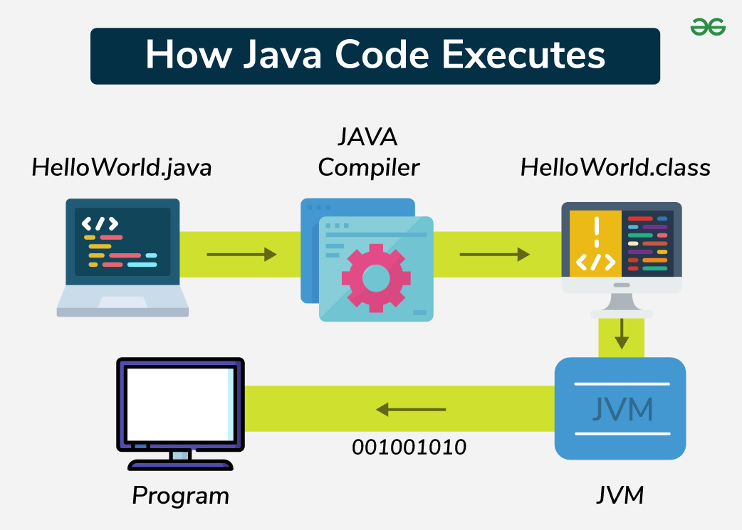

Figure . The compilation and interpretation process of Java

### Spring Boot

* Spring Boot [5] is a combination of the Spring Framework and an embedded server, allowing users to build web applications, microservices and standalone JAR applications. It supports features like Microservices, REST APIand JPA databases, making app development simpler and more efficient.



Figure . Spring Boot

* Advantages of Spring Boot:
  + It creates standalone Spring applications.
  + It makes testing web apps easier with embedded HTTP servers like Tomcat, Jetty and others. No need to distribute WAR files.
  + No XML configuration required.

### MVC model

* **MVC** [6] stands for **Model-View-Controller.**
* It is a design pattern used in software engineering.
* MVC is a software architecture pattern used to create computer user interfaces.
* MVC is divided into three connected parts; each part has its own responsibility and works independently from the others.
  + **Model**
    - Responsible for working with the **database**.
    - It contains all the functions and methods that directly query or update the data.
    - The **Controller** uses these functions to get data and sends it to View.
  + **View**
    - Is the **user interface.**
    - Contains all the elements that the user interacts with, such as menus, buttons, images, text, etc.
    - Receives data from the **Controller** and displays it.
  + **Controller**
    - Acts as the **middle layer** between Model and View.
    - Handles user requests, uses the **Model** to get data and then passes that data to the **View** to show to the user.

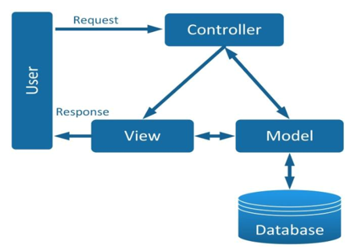

Figure . Flow of operation in the MVC model

* MVC workflow
  + First, a request from the user is sent from the client to the server.
  + Then, the Controller, based on the user’s request, communicates with the Model to get the required data from the database.
  + Finally, the Controller sends the retrieved data to the View, which displays it to the user in the browser.
* Three-tier model [7]: This is a common source code structure used in Spring Boot applications. Specifically, the application is divided into three tiers (or layers) as follows:
  + Presentation layer: This layer interacts directly with the user. It can include Views and Controllers (in traditional MVC) or APIs (in RESTful applications).
  + Business logic layer: This layer contains the core logic of the application. Most of the application’s code resides here. It is responsible for processing data and enforcing business rules.
  + Data access layer: This layer interacts directly with the database, executing queries and returning results to the business logic layer.

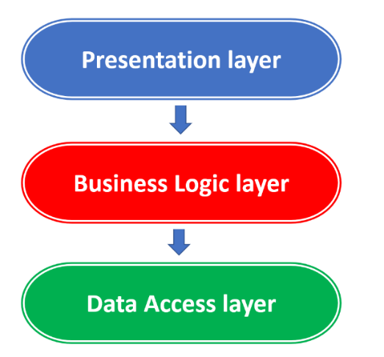

Figure . Three-tier architecture

* By combining the two models, we get a complete Spring Boot application consisting of the following components:
  + Controller: The controller returns a View (which contains the data ready for display in HTML format) or a Model represented through an API for the View (the View is separately written using React, Vue or Angular).
  + Service: The Service contains the logic and processing code. When the Controller requests it, the Service will handle the request and return the data (in the form of a Model) back to the Controller. The Controller will then pass this data to the View as described earlier.
  + Repository: The Repository is used by the Service to interact with the database. The Repository directly interacts with the database, reading and writing data and then returning the results to the Service.

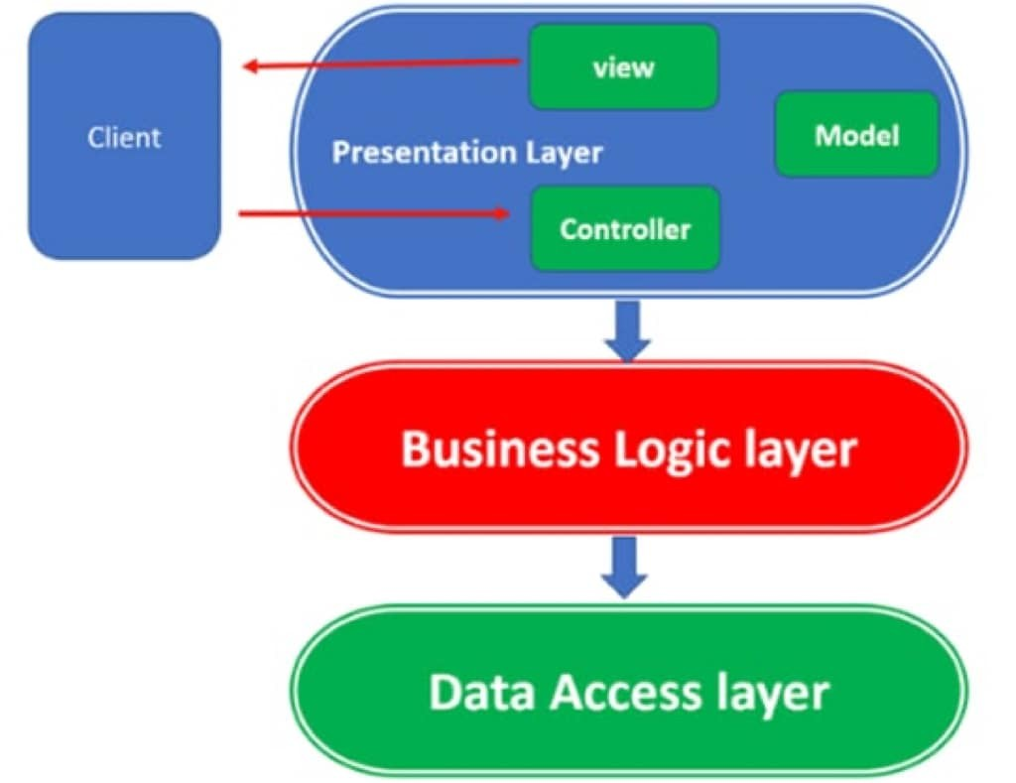

Figure . Three-Tier architecture vs MVC pattern

### MySQL

* MySQL [8] is an open-source, relational database management system (RDBMS) that uses Structured Query Language (SQL) to manage and manipulate data. It is one of the most popular database systems used in web applications, known for its speed, reliability and ease of use.



Figure . MySQL

* Key Features of MySQL:
  + **Developed by Oracle Corporation.**
  + **Supports multiple platforms:** MySQL runs on operating systems such as Windows, Linux and macOS.
  + **It is widely used by developers** due to its scalability, data security features and large community support.
* Advantages of MySQL:
  + **Open-source:** MySQL is free and open-source, allowing modification and redistribution.
  + **High performance:** MySQL offers fast data retrieval and processing for large datasets.
  + **ACID compliance:** Ensures data integrity and reliability, especially with the InnoDB storage engine.
  + **Scalability:** It supports large databases and high traffic with features like partitioning and clustering.
  + **Variety of storage engines**: MySQL offers multiple storage engine options (e.g., InnoDB, MyISAM) for flexible usage.
  + **Replication**: It supports master-slave replication for data redundancy and high availability.

## Overview of frontend development

### React

* React (ReactJS) [9] [10] is a free and open-source JavaScript library for building web user interfaces. It handles only the visual part (the view) and does not control how business logic or app structure is organized.



Figure . React

* Key feature of React
  + Virtual DOM:
    - Creates a lightweight copy of the DOM.
    - Compares it with the previous version to detect changes (diffing).
    - Updates only the changed parts in the actual DOM (reconciliation), improving performance.
  + Components are the basic building blocks of React that define the structure of the user interface. Each component is encouraged to be as small and independent as possible to allow for easy reuse across different parts of the application or even in other applications.
  + JSX is a syntax extension that allows users to write HTML-like code within JavaScript. In other languages, HTML and JavaScript are typically written separately. However, with JSX, React lets users combine both in the same source code file.
  + React uses one-way data binding, meaning data flows in a single direction from parent components to child components via props. This provides better control over data and helps maintain predictable behavior.
* React operates by creating an in-memory virtual DOM rather than directly manipulating the browser’s DOM. It performs necessary manipulations within this virtual representation before applying changes to the actual browser DOM.

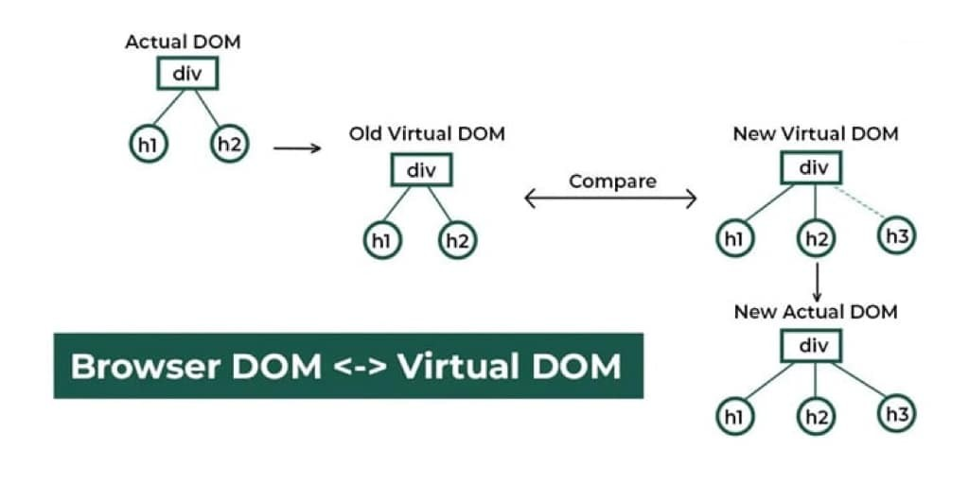

Figure . How React uses Virtual DOM

* Here’s how the process works:
  1. Actual DOM and Virtual DOM
     + Initially, an Actual DOM contains a div with two child elements: h1 and h2.
     + React maintains a previous Virtual DOM to track the UI state before any updates.
  2. Detecting Changes
     + When a change occurs (e.g., adding a new h3 element), React generates a New Virtual DOM.
     + React compares the previous Virtual DOM with the New Virtual DOM using a process called reconciliation.
  3. Efficient DOM Update
     + React identifies the differences (in this case, the new h3 element).
     + Instead of updating the entire DOM, React updates only the changed part in the New Actual DOM, making the update process more efficient.
* ReactJS lifecycle

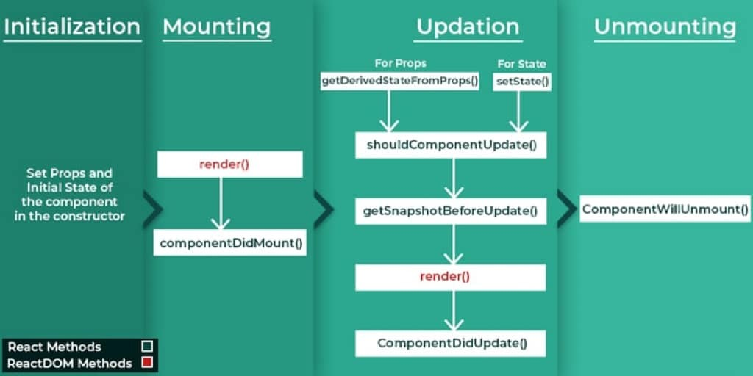

Figure . ReactJS lifecycle

* 1. Initialization: This is the stage where the component is constructed with the given Props and default state. This is done in the construction of a Component Class.
  2. Mounting phase
     + Constructor: The constructor method initializes the component. It’s where users set up the initial state and bind event handlers.
     + **render():** This method returns the JSX representation of the component. It’s called during initial rendering and subsequent updates.
     + **componentDidMount()**: After the component is inserted into the DOM, this method is invoked. Use it for side effects like data fetching or setting timers.
  3. Updating phase
     + **componentDidUpdate(prevProps, prevState)**: Called after the component updates due to new props or state changes. Handle side effects here.
     + **shouldComponentUpdate(nextProps, nextState)**: Determines if the component should re-render. Optimize performance by customizing this method.
     + **render():** Again, the render() method reflects changes in state or props during updates.
  4. Unmounting phase
     + **componentWillUnmount()**: Invoked just before the component is removed from the DOM. Clean up resources (e.g., event listeners, timers).

### ChakraUI

* Chakra UI [11] is a modern, modular and accessible component library for React applications. Its main goal is to simplify the development of user interfaces by providing a set of pre-built, composable and themeable components that follow best practices for accessibility and responsive design.



Figure . Chakra UI

* Unlike traditional UI libraries that often require developers to write a lot of custom CSS or rely on additional styling tools, Chakra UI is built with a focus on developer experience. It uses a style props system that allows developers to apply CSS directly to components using simple and intuitive syntax, reducing or even eliminating the need for separate stylesheets.
* With Chakra UI, users can easily build sleek, modern interfaces that are highly customizable and compliant with UI/UX standards. The library offers a wide range of commonly used components such as buttons, forms, navigation bars, modals and more helping users get started quickly without having to build everything from scratch.

## Overview of deployment

### Amazon Web Services

* Amazon Web Services (AWS) [12] is a comprehensive cloud computing platform developed by Amazon and launched in 2006. It offers over 30 diverse services including storage, computing, databases, search, and human intelligence integration. AWS infrastructure is globally distributed, with multiple Availability Zones in each region such as the US, Brazil, Ireland, Singapore, Japan, and Australia, ensuring high availability and reliability.



Figure . Amazon Web Services

* Key benefits of AWS include:
  + Cost efficiency: The “pay-as-you-go” model allows businesses to save money and manage budgets effectively.
  + Flexible scalability: Easily scale systems up or down to match changing demand.
  + No capacity planning needed: There's no need to predict future resource needs; services can be started or stopped as needed.
  + Fast deployment: IT teams can launch services within minutes instead of spending weeks on infrastructure setup.
  + Reduced data center maintenance cost: Focus on enhancing user experience instead of maintaining hardware.
  + Global deployment in minutes: With just a few clicks, services can go live globally with low latency, stable infrastructure, and optimized cost.

### Amazon Simple Storage Service

* Amazon S3 [13] is an object storage service designed to store and retrieve any amount of data from anywhere. It offers a simple, durable, highly available, high-performance, and secure storage solution with virtually unlimited scalability at very low cost.



Figure . Amazon Simple Storage Service

* Key Advantages of Amazon S3
  + High Durability: Protects data with high durability.
  + High Availability: Ensures data is accessible whenever needed.
  + Flexible Scalability: Automatically scales storage capacity based on demand.
  + Cost-Effective: Pay only for the storage and bandwidth users use.
  + Strong Security: Supports data encryption and fine-grained access control.
  + Easy Data Management: Features versioning and organizing data using buckets.
  + Wide Integration: Seamlessly integrates with various AWS services.

### Amazon Relational Database Service

* Amazon RDS [14] is a fully managed relational database service provided by Amazon Web Services. It allows users to easily deploy, operate, and scale a relational database in the cloud without the need to manage the underlying infrastructure, unlike traditional on-premises systems.



Figure . Amazon Relational Database Service

* Key Features of Amazon RDS with MySQL:
  + Easy setup and configuration: Databases can be created in just a few steps using the AWS Management Console.
  + Automated backup and recovery: Supports daily backups and point-in-time recovery to ensure data safety.
  + Scalability: Easily upgrade compute capacity (vCPU, RAM) and increase storage size based on application needs.
  + High availability: Supports Multi-AZ deployment to increase fault tolerance (this feature was not used in this project).
  + Integrated monitoring: Performance metrics and health status can be monitored via Amazon CloudWatch.
  + Security: Supports VPC isolation, configurable access control (e.g., allowing access on port 3306 only from backend IPs), and password protection for database access.

### Amazon Elastic Compute Cloud

* Amazon EC2 [12] is a cloud computing service from AWS that enables users to launch and manage virtual servers with flexibility and speed. EC2 eliminates the need for upfront hardware investment, allowing applications to scale up or down based on real-time demand without the need for traffic forecasting.



Figure . Amazon Elastic Compute Cloud

* Users can launch **instances** (virtual machines) using preconfigured Amazon Machine Images that include the operating system and required software. EC2 offers various instance types tailored for different needs in terms of CPU, memory, and networking.
* Security is managed through **key pairs**, which control login access. EC2 supports temporary storage through instance store and persistent storage via Amazon EBS. Resources can be deployed across multiple regions and Availability Zones to enhance reliability and fault tolerance.

### Vercel

* Vercel [15] is a cloud platform specifically designed for deploying and managing the frontend of web applications quickly, easily, and efficiently. It supports popular technologies like Next.js, React, Vue, and Svelte, and integrates seamlessly with GitHub, GitLab, and Bitbucket for automatic deployment.



Figure . Vercel

* Key Benefits of Vercel:
  + Easy and automatic deployment: Connect the user’s Git repository (e.g., GitHub or GitLab), and Vercel automatically builds and deploys their site whenever users push new code. No complex server or network configuration required.
  + High performance with global infrastructure: Frontend code is distributed via a global CDN, ensuring fast page loads for users everywhere.
  + Preview deployments: Every pull request generates a unique preview link, allowing users to review changes before merging them into production.
  + Built-in analytics and monitoring: Vercel provides dashboards with insights into site performance, page load times, accessibility, and more.

## Chapter conclusion

In this chapter, I reviewed key technologies and frameworks essential for modern software development. I covered popular programming languages like Python and Java, tools such as Jupyter Notebook and powerful frameworks like Spring Boot with its MVC and three-tier architecture.

I also discussed MySQL’s strengths as a reliable and scalable database system. On the frontend side, we introduced ReactJS with its component-based design and Virtual DOM, along with Chakra UI for faster and easier UI development.

In addition to development tools, I also explored deployment platforms and services that help bring applications into production. These include AWS EC2 for hosting backend services, RDS for managed relational databases, and S3 for object storage. For frontend deployment, I used Vercel, a cloud platform optimized for hosting Frontend.

Together, these technologies form a solid foundation for building, deploying, and maintaining modern, scalable applications.

# SYSTEM DESIGN AND ANALYSIS

## Business analysis

### Buyer's business

* Visiting customers
  + View property list: can view all properties posted on the system.
  + View property details: view description, images, price, area, number of rooms, etc. At the same time, the real estate price will be displayed as determined by the system.
  + Register account: if users want to save posts or make transactions, visitors must register an account.
  + Search and filter properties: Search by keywords, filter by characteristics of the property.
* **Members** are those who have registered an account and can use all the features:
  + All rights of visitors.
  + Update profile and account information: Change contact information and full name.
  + Upgrade account: choose an account upgrade package to use more features and pay directly through the payment gateway.
  + View transaction history: track completed or pending transactions.
  + Buyer accounts can also post properties for sale but are limited to 3.
  + Manage personal posts allows users to edit, update, and delete their uploaded real estate listings. This feature is integrated with toxicity content and NSFW image detection system.
  + Save to favorites: add properties user’s favorites list for easy access later.

### Broker's business

* Brokerage account is a registered and upgraded account
* Having all the rights of a member
* This account will be used for additional features of the system: predicting real estate trends.
* The article limits the posts that can be posted by this account to 30

### Admin's business

* Account status control: lock or unlock client accounts.
* Post moderation: review, approve or reject real estate posts.

## System design

### Use-case diagram

#### General use-case diagram

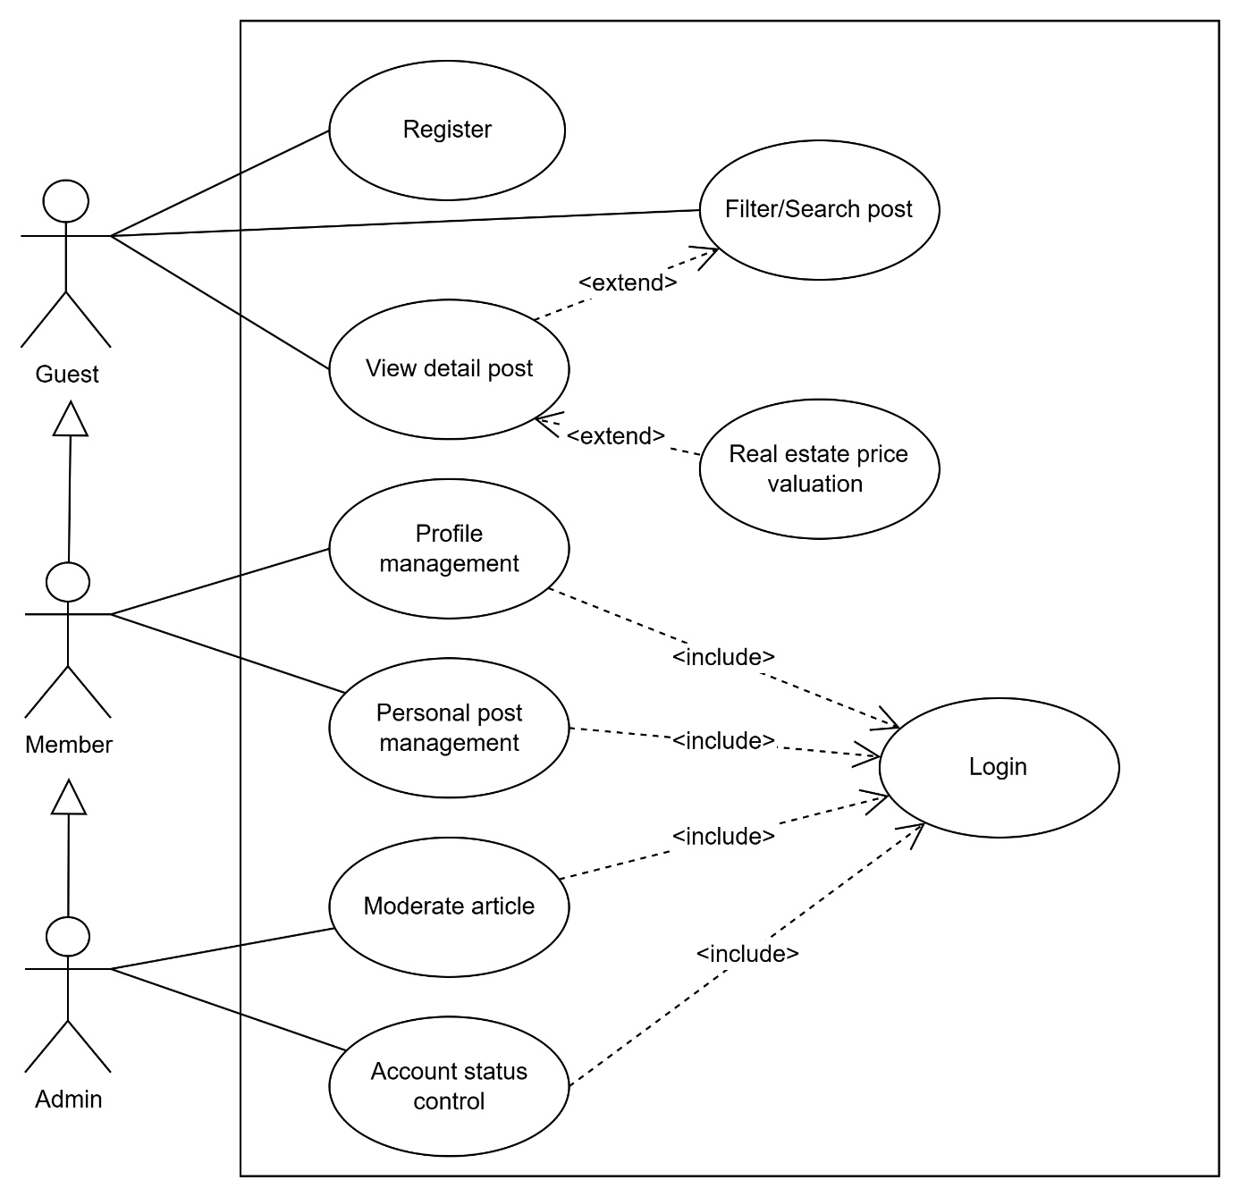

Figure . General use case diagram

* Use case specification: Register

Table . Register function specification

|  |  |
| --- | --- |
| Use case name | Register |
| Use case ID | UC001 |
| Actor | Guest |
| Description | The guest registers for an account to become a member |
| Prerequisites | None |
| Post-conditions | A new account is successfully created |
| Main flow | 1. The guest accesses the registration page 2. Guest enters the required information: phone, email, password, and confirms password 3. Guest clicks the “register” button 4. The system validates the information 5. The system creates a new account 6. The system displays a success message |
| Alternative flows | 4a. Invalid information:   1. The system displays an error message 2. Return to step 2   4b. Phone or email already exists:   1. The system displays an error message 2. Return to step 2 |
| Relationships with other use cases | <include>: none  <extend>: none |

* Use case specification: Filter/Search post

Table . Filter/search post function specification

|  |  |
| --- | --- |
| Use case name | Filter/Search post |
| Use case ID | UC002 |
| Actor | Guest, member, admin |
| Description | The guest searches and filters posts based on selected criteria |
| Prerequisites | None |
| Post-conditions | A list of posts matching the search/filter criteria is displayed |
| Main flow | 1. The guest accesses the search page 2. The guest enters a keyword or selects filters 3. The system processes the search request 4. The system displays the list of matching posts |
| Alternative flows | 4a. No results found:   1. The system displays a “Không tìm thấy bài viết” message |
| Relationships with other use cases | <include>: none  <extend>: View a detailed post |

* Use case specification: View a detailed post

Table . View a detailed post function specification

|  |  |
| --- | --- |
| Use case name | View a detailed post |
| Use case ID | UC003 |
| Actor | Guest, member, admin |
| Description | The guest views the detailed content of a post |
| Prerequisites | The post exists in the system |
| Post-conditions | The detailed content of the post is displayed |
| Main flow | 1. The guest clicks on a post title from the list 2. The system loads the post content 3. The system displays the post details |
| Alternative flows | 2a. No results found:   1. The system displays a “Không tìm thấy bài viết” message |
| Relationships with other use cases | <include>: none  <extend>: Real estate price valuation |

* Use case specification: Real estate price valuation

Table . Real estate price valuation function specification

|  |  |
| --- | --- |
| Use case name | Real estate price valuation |
| Use case ID | UC004 |
| Actor | Guest, member, admin |
| Description | The guest uses the system to estimate the price of a real estate property |
| Prerequisites | The guest selected a post |
| Post-conditions | The system displays an estimated price for the real estate |
| Main flow | 1. The system displays the selected post details 2. The guest clicks the “Định giá” button 3. The system processes the input data and runs the price estimation model 4. The system displays the estimated price |
| Alternative flows | 3a. Failure to value:   1. The system displays “Hệ thống định giá thất bại” message |
| Relationships with other use cases | <include>: none  <extend>: none |

* Use case specification: Login

Table . Login function specification

|  |  |
| --- | --- |
| Use case name | Login |
| Use case ID | UC005 |
| Actor | Member, admin |
| Description | The user logs into the system to access features |
| Prerequisites | The user already has an account  The account is not locked |
| Post-conditions | The user logs in successfully |
| Main flow | 1. The user accesses the login page 2. The user enters their phone and password 3. The user clicks the “Đăng nhập” button 4. The system verifies the login information 5. The system creates a session for the user 6. The system redirects the user to the homepage 7. A success message is displayed |
| Alternative flows | 3a. Incorrect login information:   1. The system displays an error message 2. Return to step 2   3b. Account is locked:   1. The system displays an account locked message 2. Return to step 2 |
| Relationships with other use cases | <include>: none  <extend>: none |

#### Admin use-case diagram

* Account status control

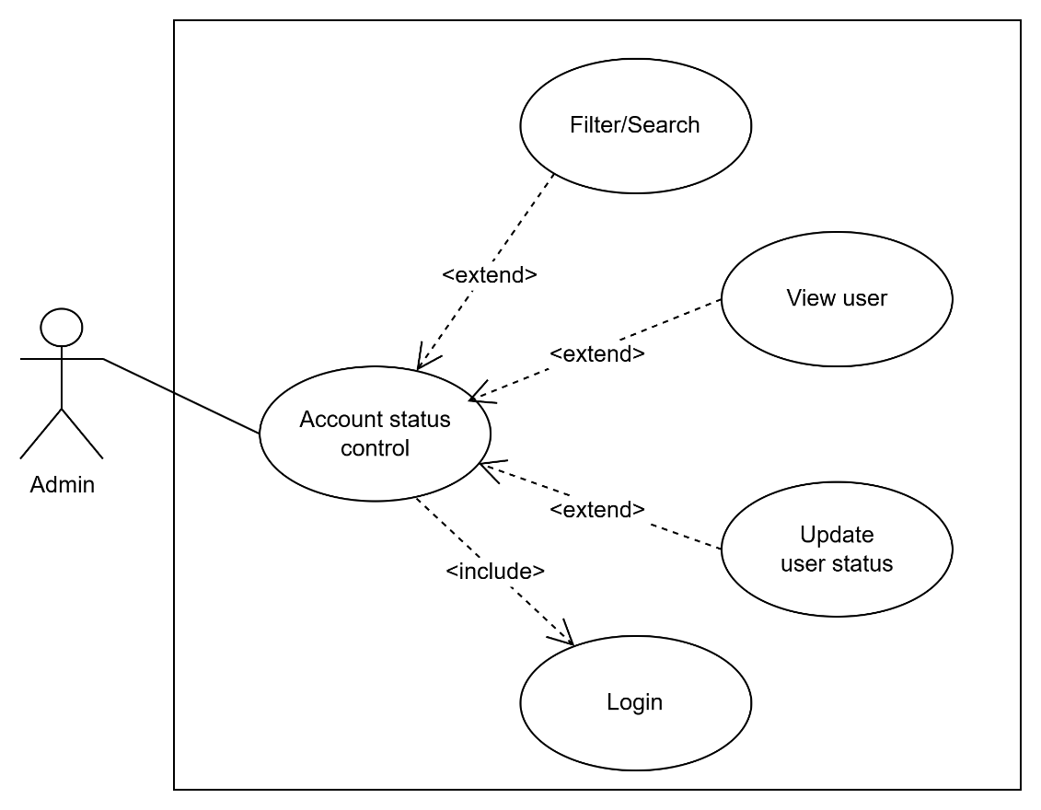

Figure . User management use-case diagram

* + Use case specification: Filter/Search user

Table . Filter/Search user function specification

|  |  |
| --- | --- |
| Use case name | Filter/Search post |
| Use case ID | UC_A001 |
| Actor | Admin |
| Description | The admin searches and filters user information based on specific criteria |
| Prerequisites | The admin has successfully logged in |
| Post-conditions | A list of users is displayed based on the search/filter criteria |
| Main flow | 1. The admin accesses the user management page 2. The admin enters keywords or selects filters 3. The system processes the search request 4. The system displays the matched users |
| Alternative flows | 3a. No results found:   1. The system displays a “Không tìm thấy người dùng” message |
| Relationships with other use cases | <include>: none  <extend>: none |

* + Use case specification: View user

Table . View user function specification

|  |  |
| --- | --- |
| Use case name | View user |
| Use case ID | UC_A002 |
| Actor | Admin |
| Description | The admin views the detailed information of a specific user |
| Prerequisites | The admin has successfully logged in |
| Post-conditions | The user’s detailed information is fully displayed |
| Main flow | 1. The admin accesses the user list 2. The admin clicks on the view button 3. The system loads user details 4. The system displays user information |
| Alternative flows | 3a. No results found:   1. The system displays a “Không tìm thấy tài khoản” message |
| Relationships with other use cases | <include>: none  <extend>: none |

* + Use case specification: Update user status

Table . Update user status function specification

|  |  |
| --- | --- |
| Use case name | Update user status |
| Use case ID | UC_A003 |
| Actor | Admin |
| Description | The admin changes the status or information of a user |
| Prerequisites | The admin has successfully logged in  The user exists in the system |
| Post-conditions | The user information is updated |
| Main flow | 1. Admin accesses the user list 2. Admin clicks on the lock/unlock button 3. Display a warning 4. Admin confirms the change 5. The system updates the database 6. The system displays a success message |
| Alternative flows | 4a. Admin rejects the change:   1. End use case |
| Relationships with other use cases | <include>: none  <extend>: none |

* Post moderation

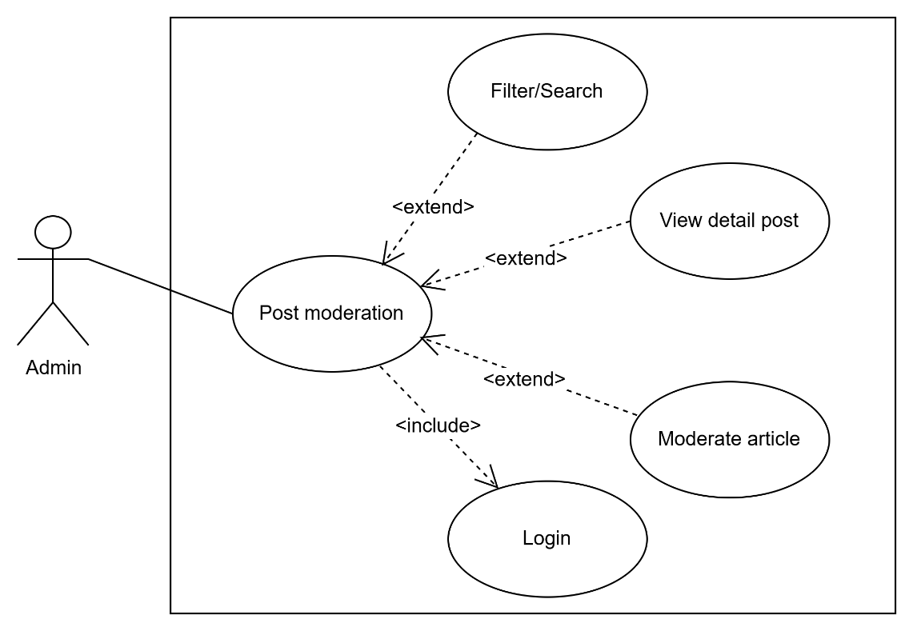

Figure . Post moderation use case diagram

* + Use case specification: Moderate post

Table . Moderate post function specification

|  |  |
| --- | --- |
| Use case name | Moderate post |
| Use case ID | UC_A003 |
| Actor | Admin |
| Description | The admin reviews and approves or rejects a post submitted by a member |
| Prerequisites | The admin has successfully logged in  There are posts in the system |
| Post-conditions | The status of the post is updated |
| Main flow | 1. The admin accesses the post moderation page 2. The system displays a list of pending posts 3. The admin selects a post to review 4. The system displays the post content and metadata 5. The admin chooses to approve or reject the post 6. The system updates the post status accordingly 7. The system displays a success message |
| Alternative flows | 5a. Admin closes post moderation:   1. End use case |
| Relationships with other use cases | <include>: none  <extend>: none |

#### Member use-case diagram

* Profile management

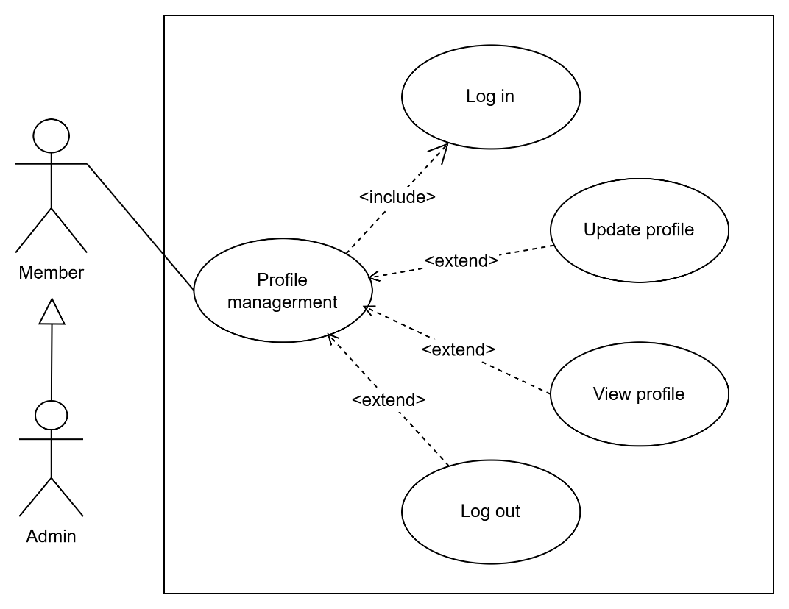

Figure . Profile management use case diagram

* + Use case specification: View profile

Table . View profile function specification

|  |  |
| --- | --- |
| Use case name | View profile |
| Use case ID | UC_M001 |
| Actor | Member, admin |
| Description | The user views their personal profile information. |
| Prerequisites | The user has successfully logged in  User account is active |
| Post-conditions | The status of the post is updated |
| Main flow | 1. Member clicks on “Thông tin cá nhân” 2. The system retrieves profile data from the database 3. The system displays basic information |
| Alternative flows | None |
| Relationships with other use cases | <include>: none  <extend>: none |

* + Use case specification: Update profile

Table . Update profile function specification

|  |  |
| --- | --- |
| Use case name | Update profile |
| Use case ID | UC_M002 |
| Actor | Member, admin |
| Description | The user updates their personal information in their profile. |
| Prerequisites | The user has successfully logged in  User account is active |
| Post-conditions | Profile information is updated successfully |
| Main flow | 1. Member accesses the “Thông tin cá nhân” page 2. The system displays a form with current information 3. The user modifies the necessary fields 4. The user clicks “Lưu thay đổi” 5. The system validates the data 6. System updates the information in the database 7. The system displays a success message |
| Alternative flows | 5a. Invalid information:   1. The system displays an error message 2. Return to step 3   5b. Phone or email already exists:   1. The system displays an error message 2. Return to step 3 |
| Relationships with other use cases | <include>: none  <extend>: none |

* Account upgrade management

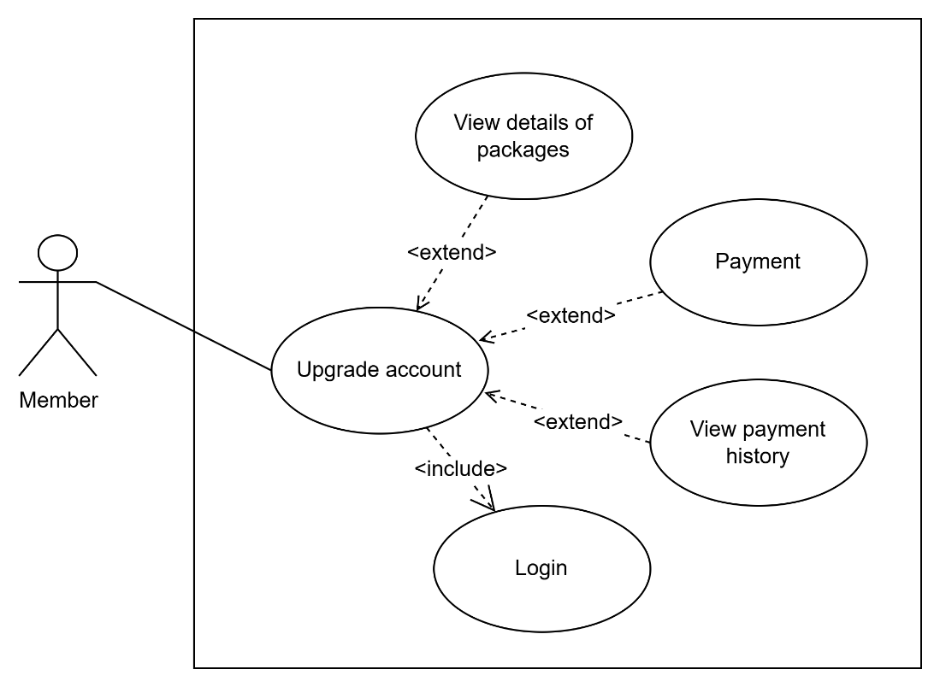

Figure . Account upgrade management use case diagram

* + Use case specification: View details of upgrade packages

Table . View the upgrade packages function specification

|  |  |
| --- | --- |
| Use case name | View details of upgrade packages |
| Use case ID | UC_M003 |
| Actor | Member |
| Description | The member views detailed information about the available account upgrade packages. |
| Prerequisites | The user has successfully logged in |
| Post-conditions | Detailed information about the available packages is displayed completely |
| Main flow | 1. Member accesses the “Nâng cấp tài khoản” page 2. The system loads the list of service packages 3. The system displays an overview of available packages |
| Alternative flows | None |
| Relationships with other use cases | <include>: none  <extend>: none |

* + Use case specification: Payment

Table . Payment function specification

|  |  |
| --- | --- |
| Use case name | Payment |
| Use case ID | UC_M004 |
| Actor | Member |
| Description | The member makes a payment to upgrade their account. |
| Prerequisites | The member is successfully logged in  The member has selected a service package |
| Post-conditions | The payment is successfully processed  The account is upgraded  An invoice is saved in the database |
| Main flow | 1. The member clicks “Mua ngay” on the selected package 2. The system displays the order confirmation pop-up 3. Member confirms the package details and price 4. The member selects a payment method 5. Member enters payment information 6. The member clicks “Thanh toán” 7. The system processes the transaction with the payment provider 8. The system receives the payment result 9. System updates the member's account 10. The system saves a transaction in the database |
| Alternative flows | 3a. Member rejects   1. Use case ends   8a. Payment failed   1. Show a message indicating payment failure 2. Use case ends |
| Relationships with other use cases | <include>: none  <extend>: none |

* + Use case specification: View payment history

Table . View transaction history function specification

|  |  |
| --- | --- |
| Use case name | View payment history |
| Use case ID | UC_M005 |
| Actor | Member |
| Description | The member views the history of payment transactions they have made. |
| Prerequisites | The member is successfully logged in |
| Post-conditions | The full payment history list is displayed. |
| Main flow | 1. The member accesses the “Lịch sử giao dịch” page. 2. The system loads the member’s transaction list. 3. The system displays the payment history table. |
| Alternative flows | 3a. No payment history   1. System displays message “Chưa thực hiện giao dịch nào” |
| Relationships with other use cases | <include>: none  <extend>: none |

* Post management

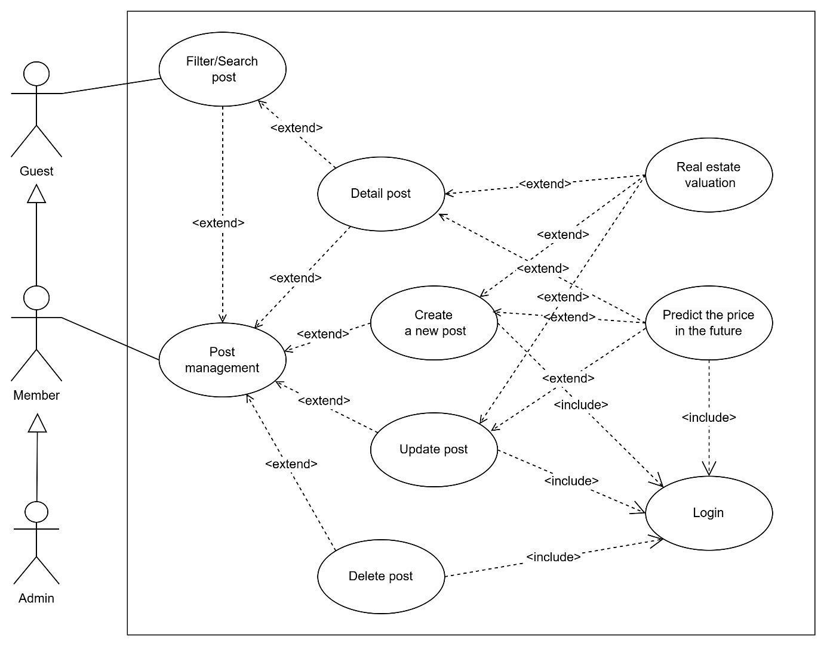

Figure . Post management use case diagram

* + Use case specification: Predict future price

Table . Predict the future price function specification

|  |  |
| --- | --- |
| Use case name | Forecast future price |
| Use case ID | UC_M006 |
| Actor | Member, admin |
| Description | The user uses the feature to predict future real estate prices |
| Prerequisites | The user has accessed the system and upgraded their account. |
| Post-conditions | The predicted price result is displayed. |
| Main flow | 1. The user enters real estate information on the create/edit post page, or simply visits the listing detail page and clicks the “Dự đoán” button. 2. The system processes the data and applies the prediction model. 3. The system displays the predicted future price result. |
| Alternative flows | 1a. Invalid information:   1. The system displays an error message 2. Return to step 1 |
| Relationships with other use cases | <include>: Login  <extend>: None |

* + Use case specification: Create a new post

Table . Create a new post function specification

|  |  |
| --- | --- |
| Use case name | Create a new post |
| Use case ID | UC_M007 |
| Actor | Member, admin |
| Description | The user creates a new real estate post to publish on the system. |
| Prerequisites | The user has accessed the system. |
| Post-conditions | The new post is created and saved in the system. |
| Main flow | 1. The user accesses the “Đăng tin” page. 2. The user enters the post information 3. The user confirms the information and submits the post. 4. The system validates the information. 5. The system saves the post and displays the message “Tạo bài viết thành công” |
| Alternative flows | 4a. Invalid information:   1. The system displays an error message 2. Return to step 2   4b. Exceeds the allowed number of posts:   1. Use case end |
| Relationships with other use cases | <include>: Login  <extend>: Forecast future price, real estate price valuation |

* + Use case specification: Update personal post

Table . Update personal post function specification

|  |  |
| --- | --- |
| Use case name | Update a post |
| Use case ID | UC_M008 |
| Actor | Member, admin |
| Description | The user edits and updates the information of an existing post. |
| Prerequisites | The user is successfully logged in.  The user has a post that needs to be updated. |
| Post-conditions | The post information is successfully updated. |
| Main flow | 1. The member accesses their post management page. 2. The member selects the post to edit. 3. The system displays the edit form with current information. 4. The member modifies the necessary information. 5. The member confirms the update. 6. The system saves the changes and displays the message “Cập nhật bài viết thành công” |
| Alternative flows | 4a. Invalid information:   1. The system displays an error message. 2. Return to step 2 |
| Relationships with other use cases | <include>: Login  <extend>: Forecast future price, real estate price valuation |

* + Use case specification: Delete personal post

|  |  |
| --- | --- |
| Use case name | Delete personal post |
| Use case ID | UC_M009 |
| Actor | Member, admin |
| Description | The user deletes a post from the system. |
| Prerequisites | User is successfully logged in  The user has a post that needs to be deleted |
| Post-conditions | The post is removed from the system |
| Main flow | 1. User accesses the post management page 2. User selects the post to delete 3. System displays confirmation dialog 4. User confirms deletion 5. System deletes the post and displays “Xoá bài viết thành công” message |
| Alternative flows | 4a. User cancels:   1. Use case ends |
| Relationships with other use cases | <include>: Login  <extend>: None |

* Favourite post management

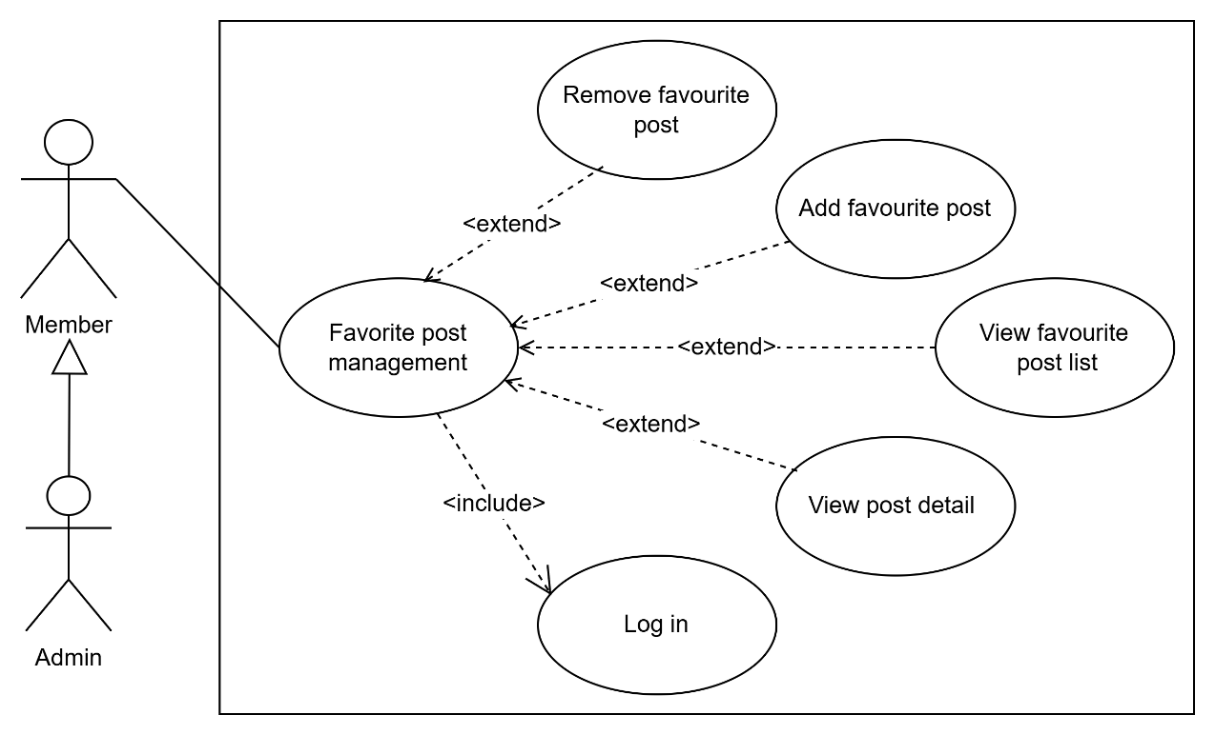

Figure . Favourite post management use case diagram

* + Use case specification: View the favourite post list

Table . View the favourite post list function specification

|  |  |
| --- | --- |
| Use case name | View the favourite post list |
| Use case ID | UC_M010 |
| Actor | Member, admin |
| Description | The user views all posts they have saved in their favourite list. |
| Prerequisites | The user is successfully logged in |
| Post-conditions | The favourite posts list is displayed |
| Main flow | 1. Member accesses the “Bài viết yêu thích của tôi” page 2. The system loads the member's favourite posts 3. System displays the favourite posts list |
| Alternative flows | 3a. No results found:   1. The system displays a “Không tìm thấy bài yêu thích” message |
| Relationships with other use cases | <include>: none  <extend>: none |

* + Use case specification: Add favourite post

Table . Add the favourite post function specification

|  |  |
| --- | --- |
| Use case name | Add a favourite post |
| Use case ID | UC_M011 |
| Actor | Member, admin |
| Description | The user adds a real estate post to their favourite list for easy access later |
| Prerequisites | The user is successfully logged in  The post list exists |
| Post-conditions | The post is added to the member's favourite list |
| Main flow | 1. The user views a post they are interested in 2. The user clicks on the love button 3. The system adds the post to the user’s favourite list 4. System displays confirmation message "Thêm bài viết vào danh sách yêu thích thành công" |
| Alternative flows | 3a. Post already in favourites:   1. The system removes the post from the member’s favourite list 2. The system displays a confirmation message “Xoá bài viết khỏi danh sách yêu thích thành công” |
| Relationships with other use cases | <include>: Login  <extend>: none |

* + Use case specification: Remove favourite post

Table . Remove the favourite post function specification

|  |  |
| --- | --- |
| Use case name | Remove favourite post |
| Use case ID | UC_M012 |
| Actor | Member, admin |
| Description | The user removes a post from their favourite list |
| Prerequisites | The user is successfully logged in and has posts in the favourite list |
| Post-conditions | The post is removed from the member's favourite list |
| Main flow | 1. User accesses their favourite posts list 2. User selects the post to remove from favourites 3. User clicks on the bin button 4. System displays confirmation dialog 5. Member confirms removal 6. System removes the post from the favourite list and displays "Xoá bài viết khỏi danh sách yêu thích thành công" |
| Alternative flows | 5a. User cancels:   1. System closes the confirmation dialog and returns to the favourite list |
| Relationships with other use cases | <include>: Login  <extend>: none |

### Activity diagram

* The stream of activities provides access to the buyer/seller's website

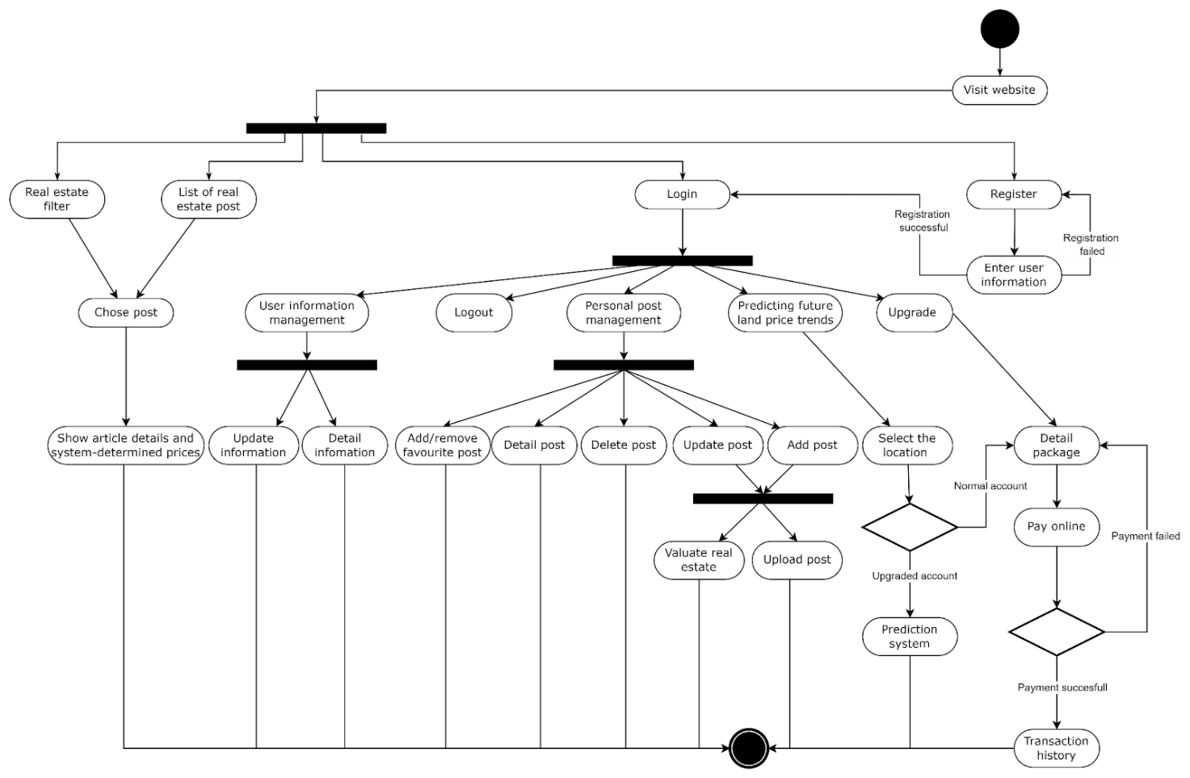

Figure . Client Operation Principle

* The stream of activities provides access to the admin website

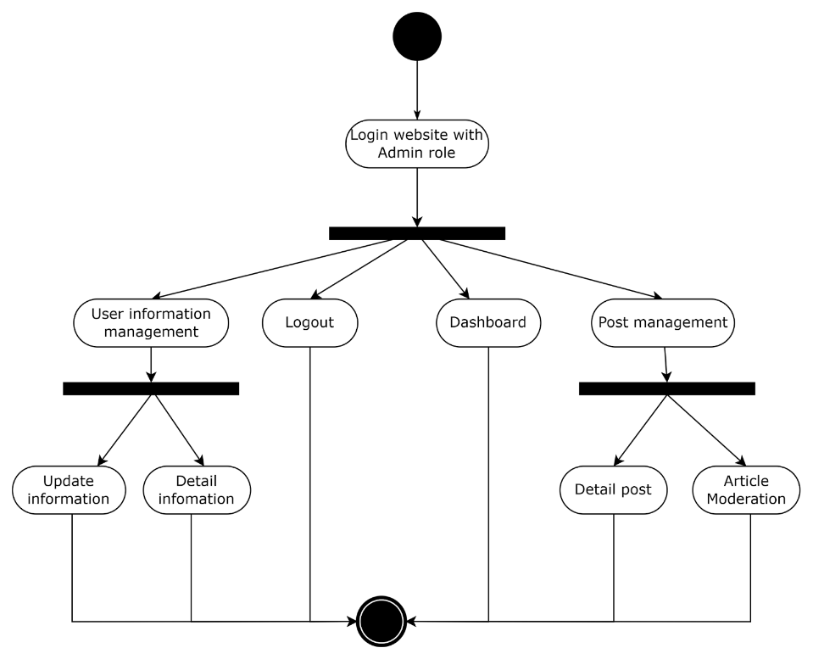

Figure . Admin Operation Principle

### Sequence diagram

* Signup flow design

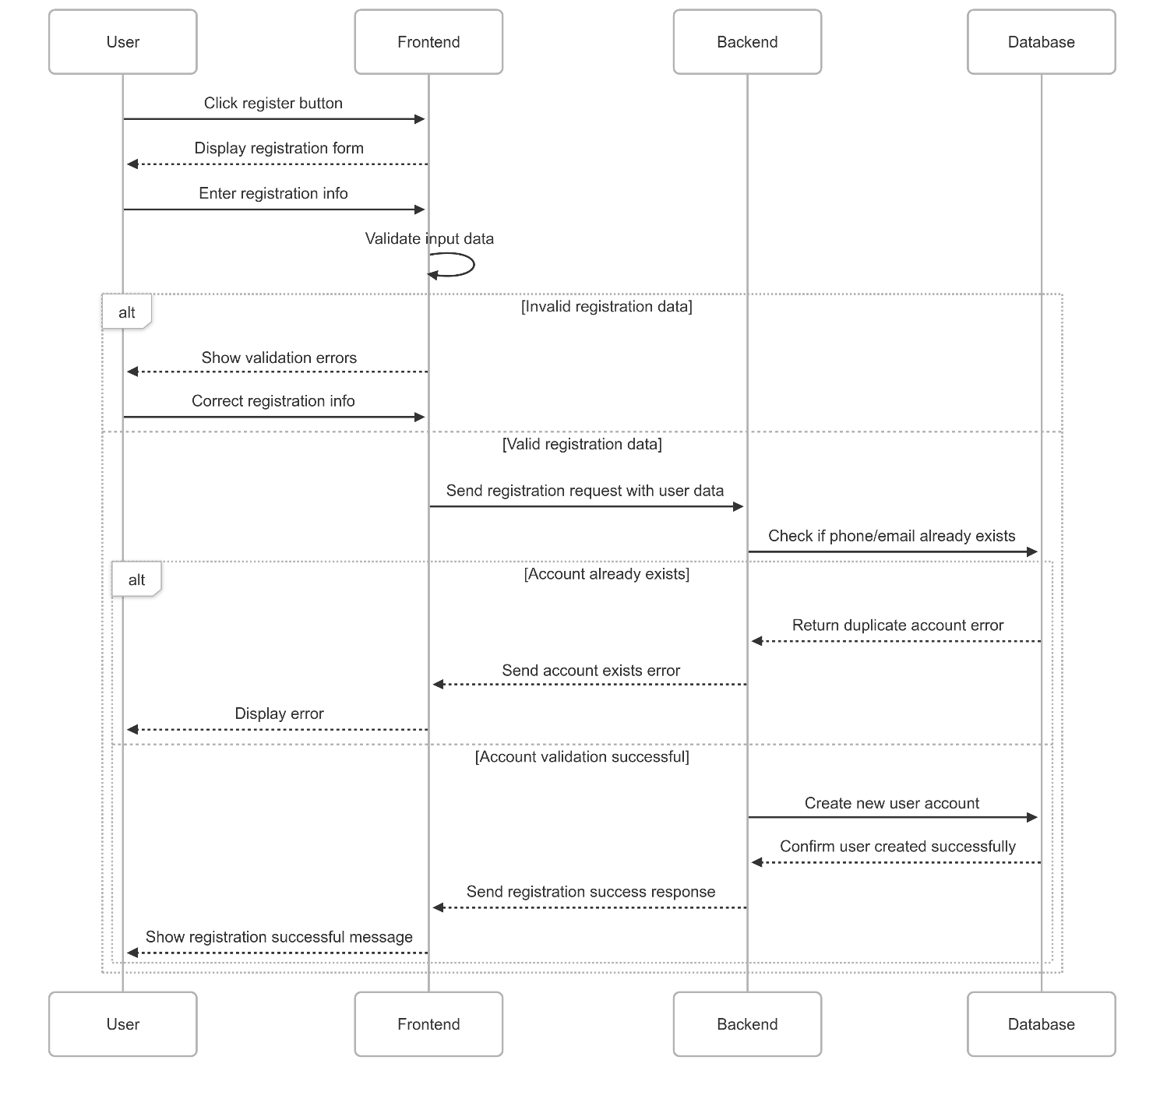

Figure . Registration flow

* Signup flow design

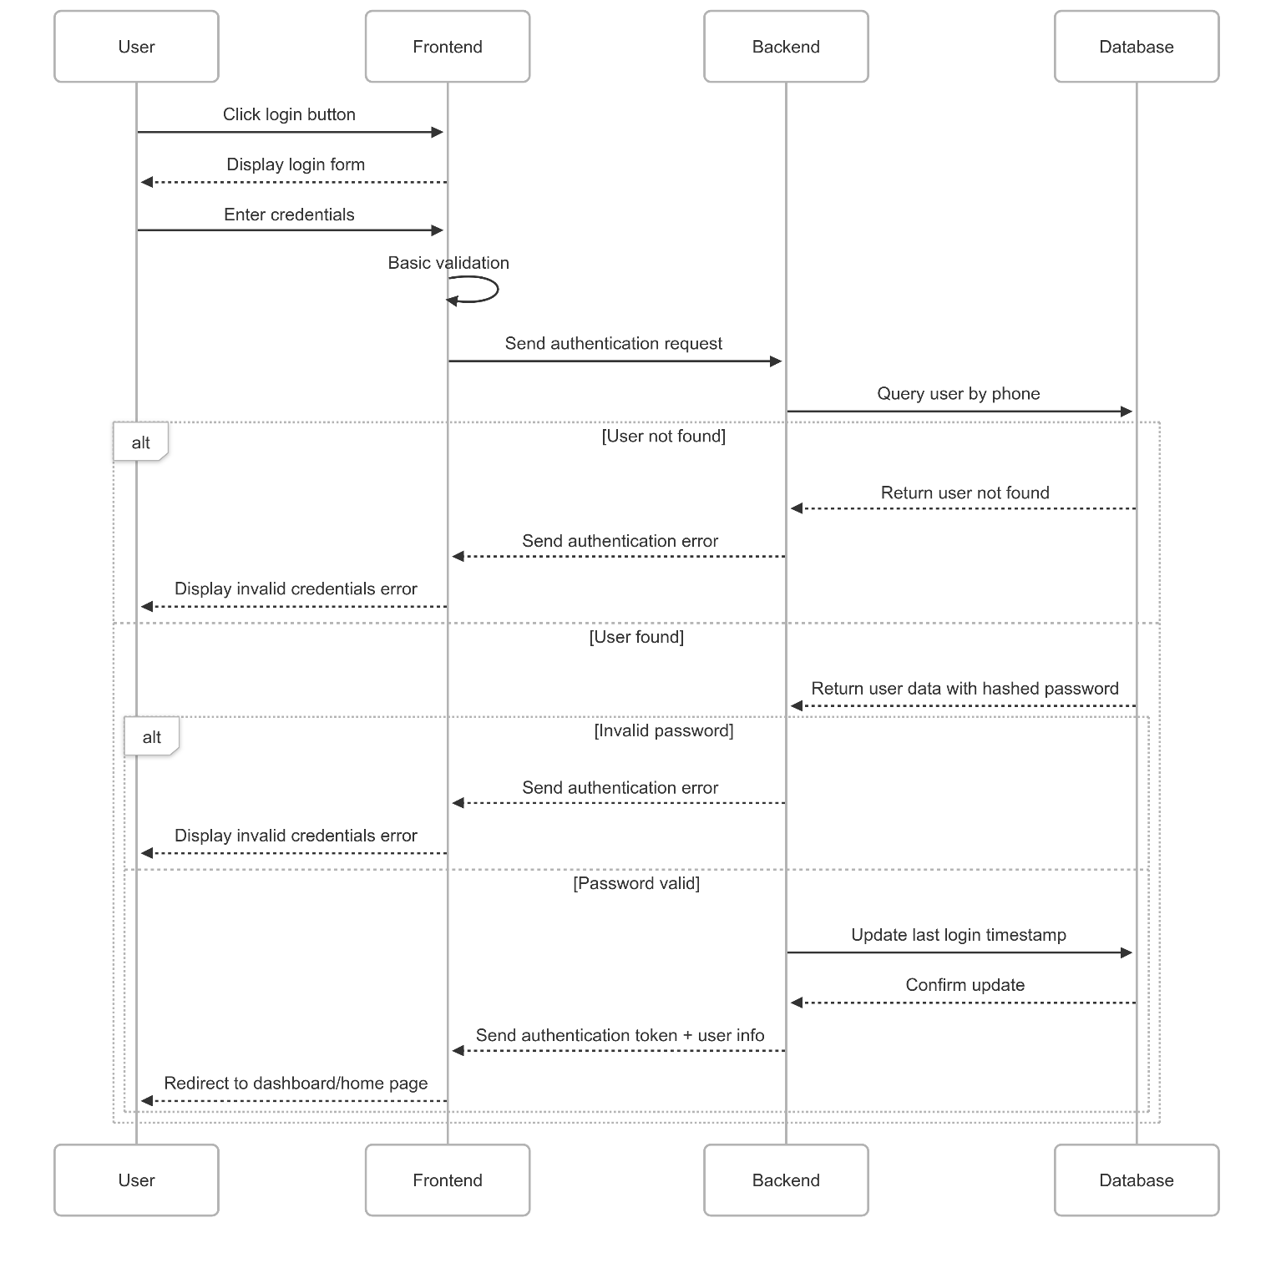

Figure . Login flow

* Real estate article management flow design
  + View & filter real estate listings

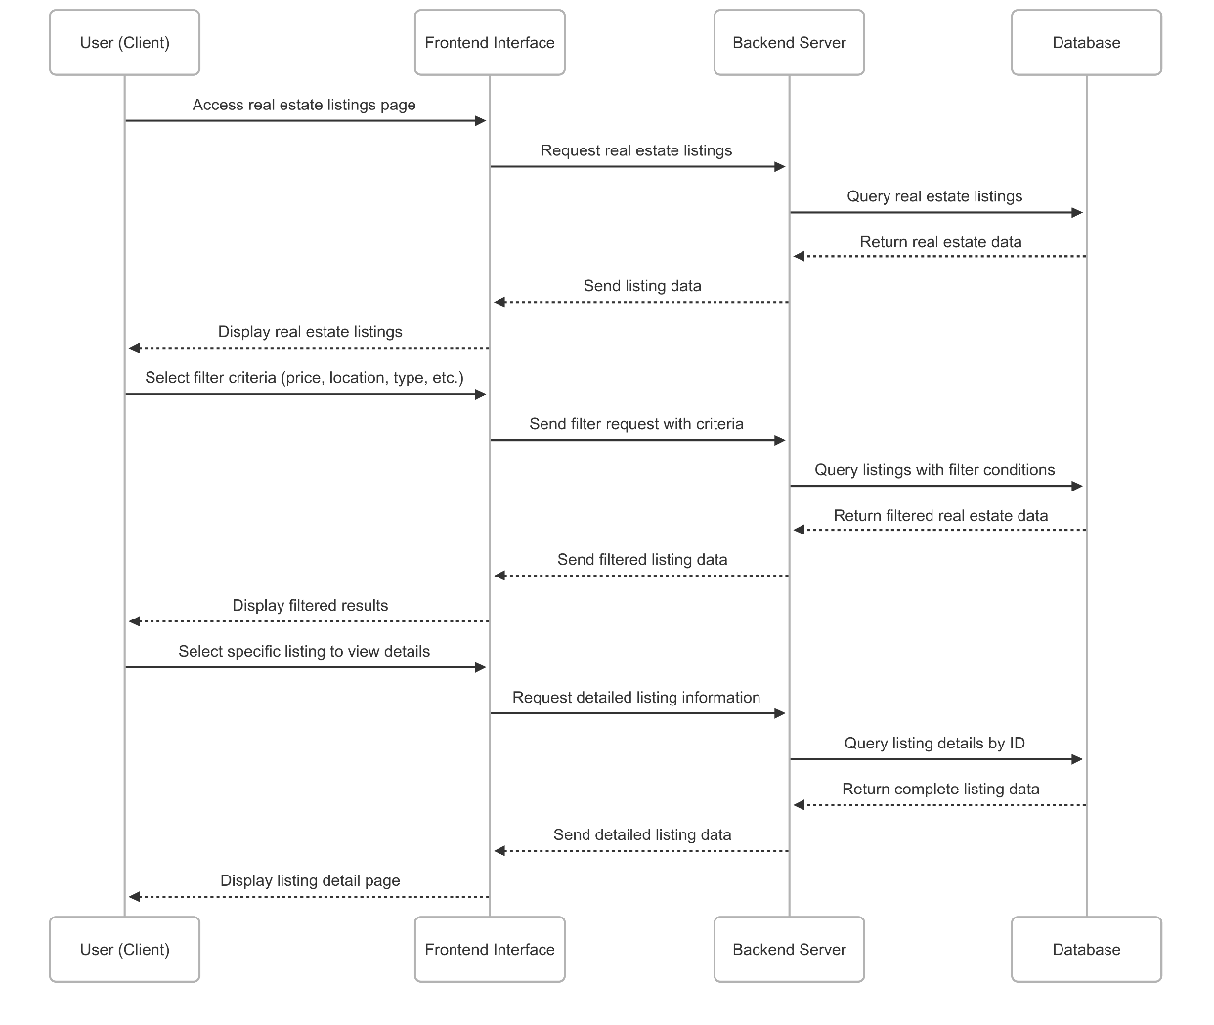

Figure . View & filter real estate flow

* + Create a real estate post

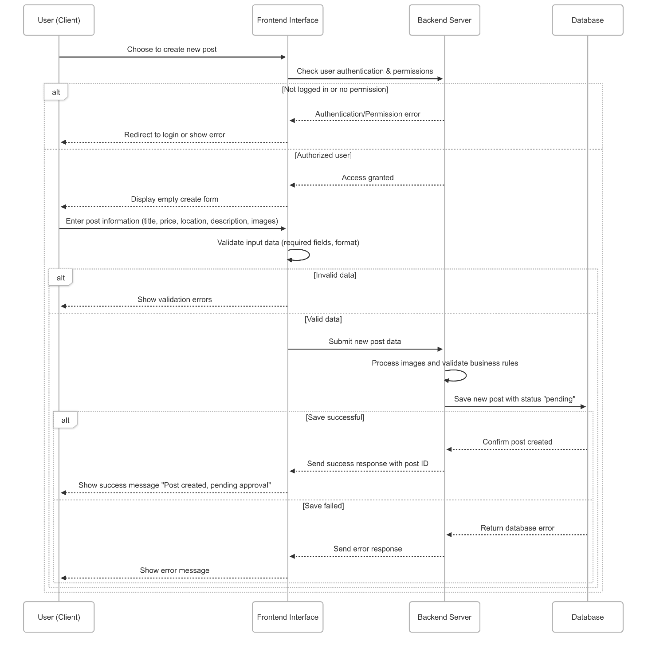

Figure . Create a real estate post flow

* + Update a real estate post

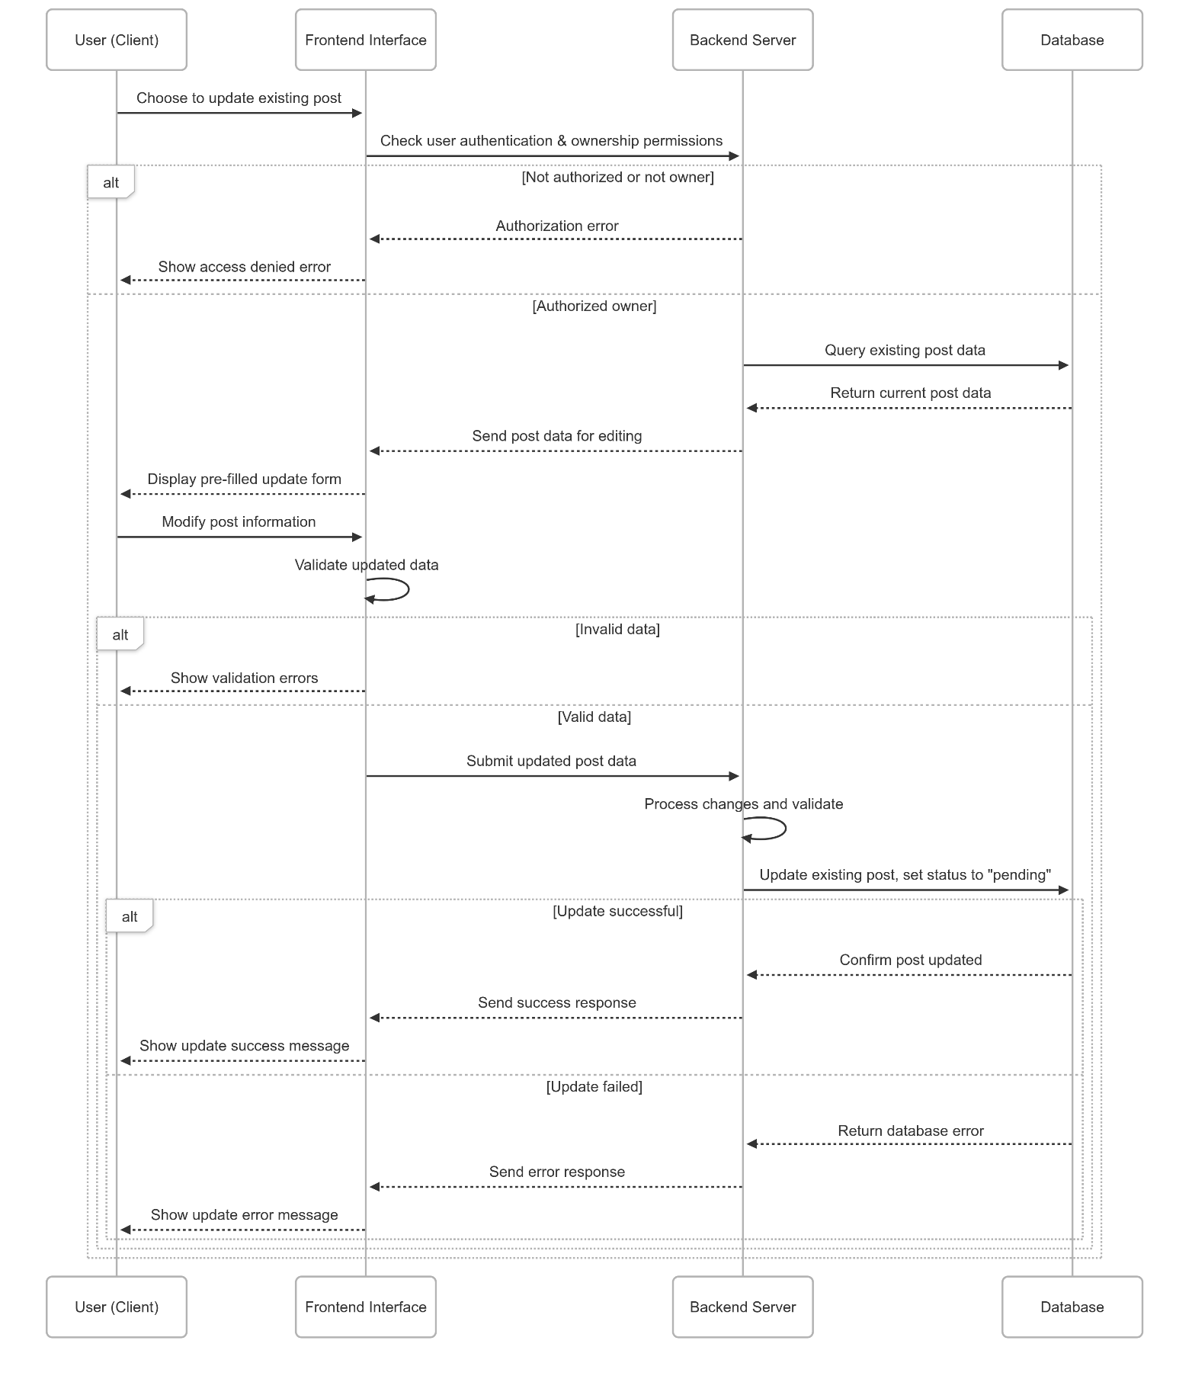

Figure . Update a real estate post flow

* + Delete a real estate post

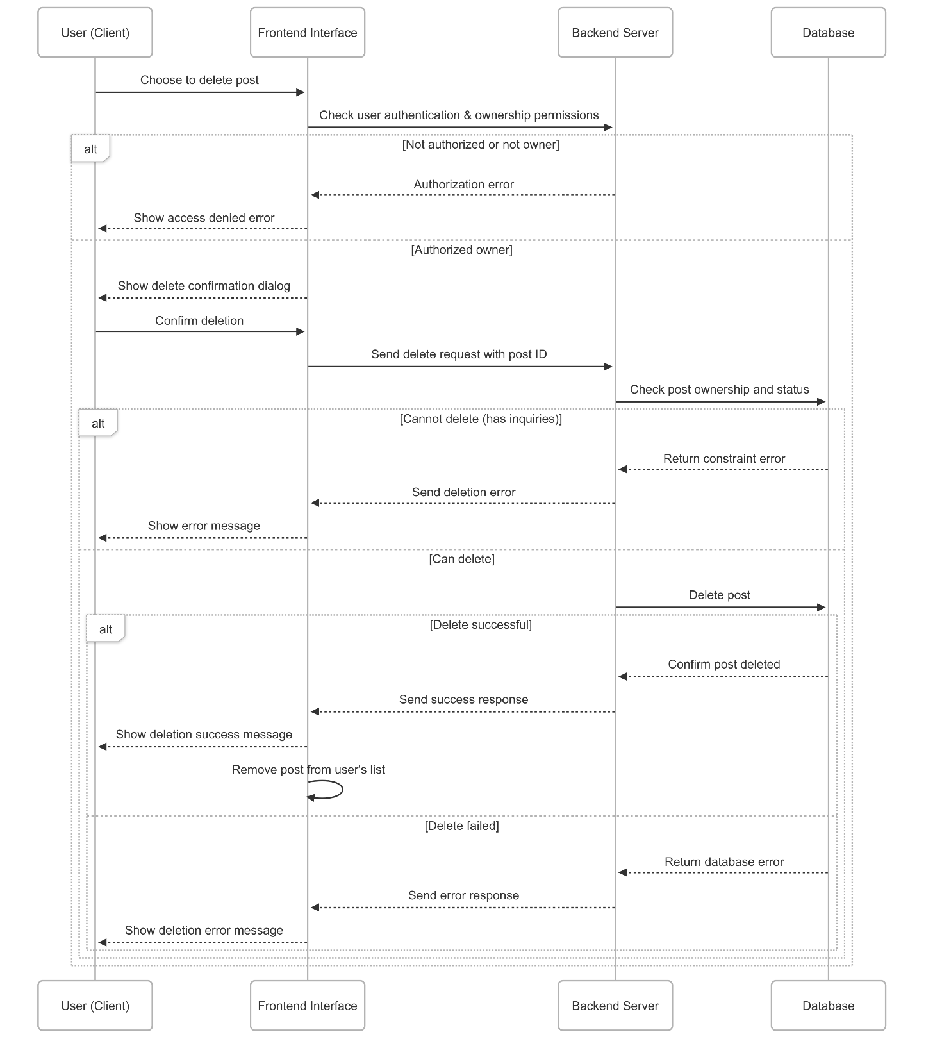

Figure . Delete a real estate post flow

* + Moderate a real estate post

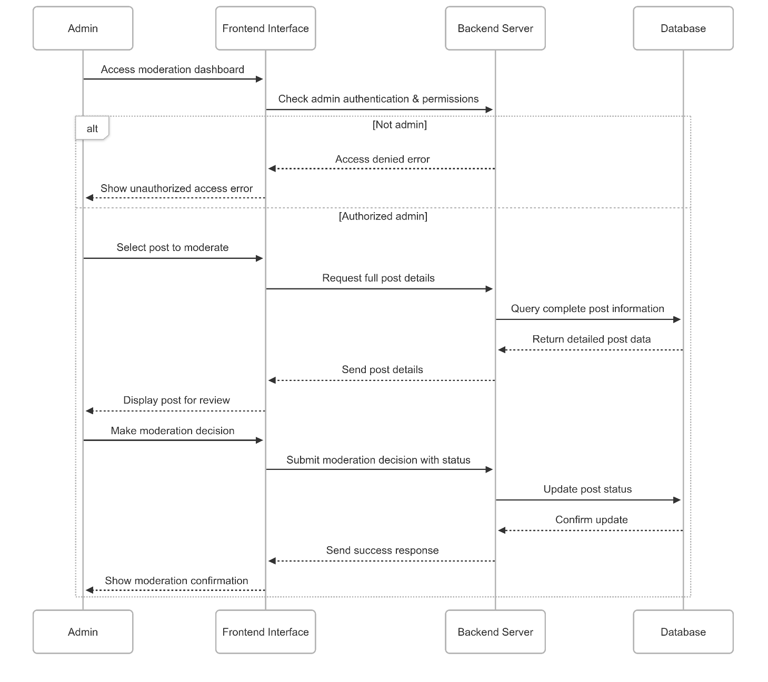

Figure . Moderate a real estate post flow

* Property valuation

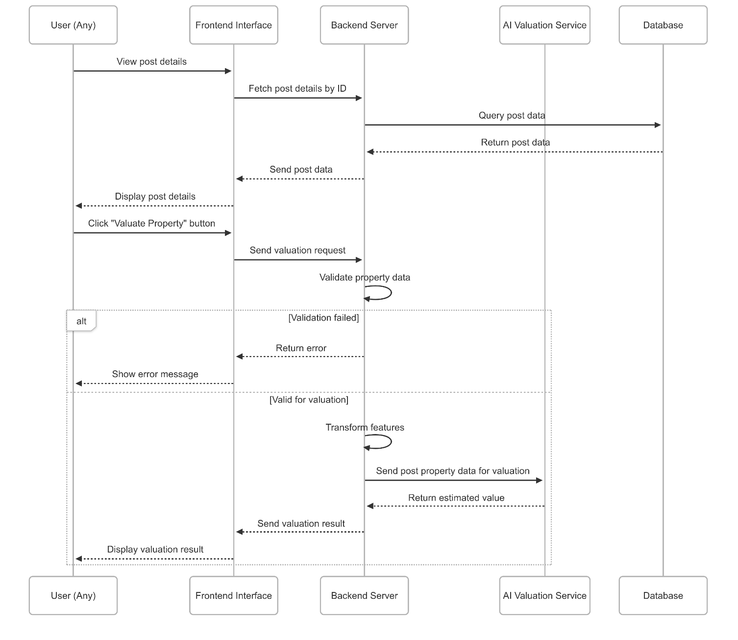

Figure . Property valuation flow

* Future real estate price prediction

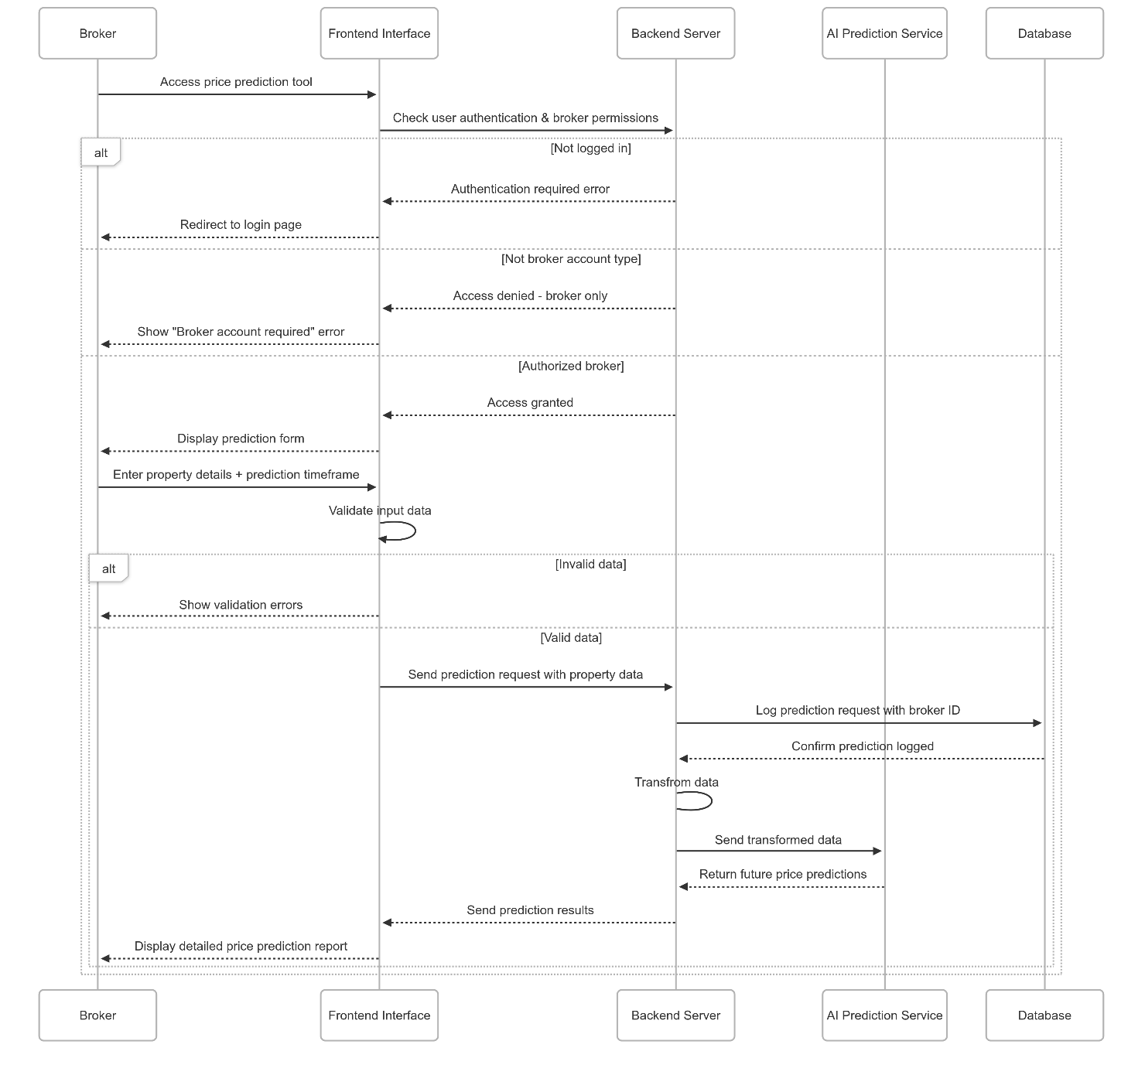

Figure . Future real estate price prediction flow

* Design of account upgrade flow, integrating online payment

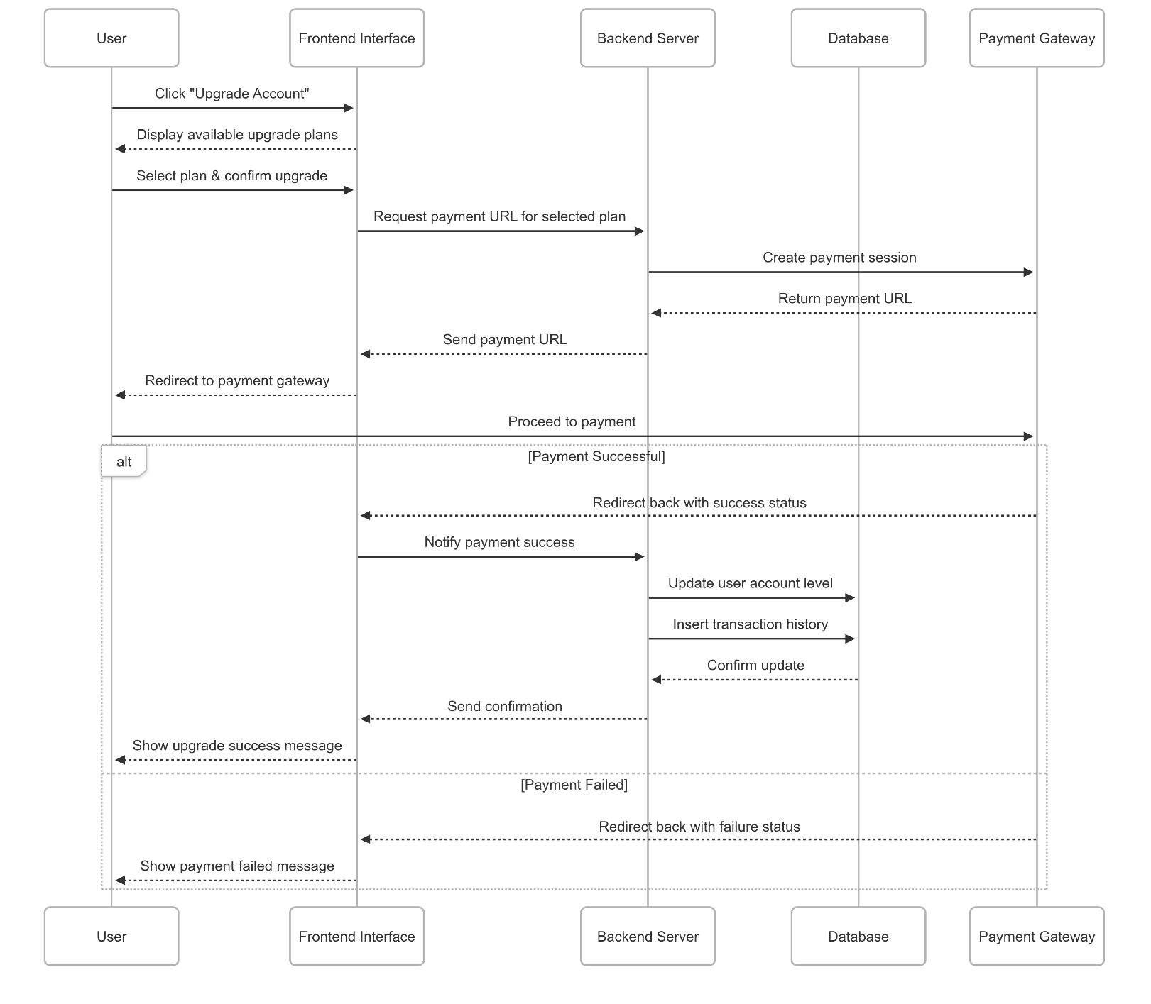

Figure . Account upgrade flow

## Database design

### Entity Relationship Diagram

The ER entity relationship model is represented below

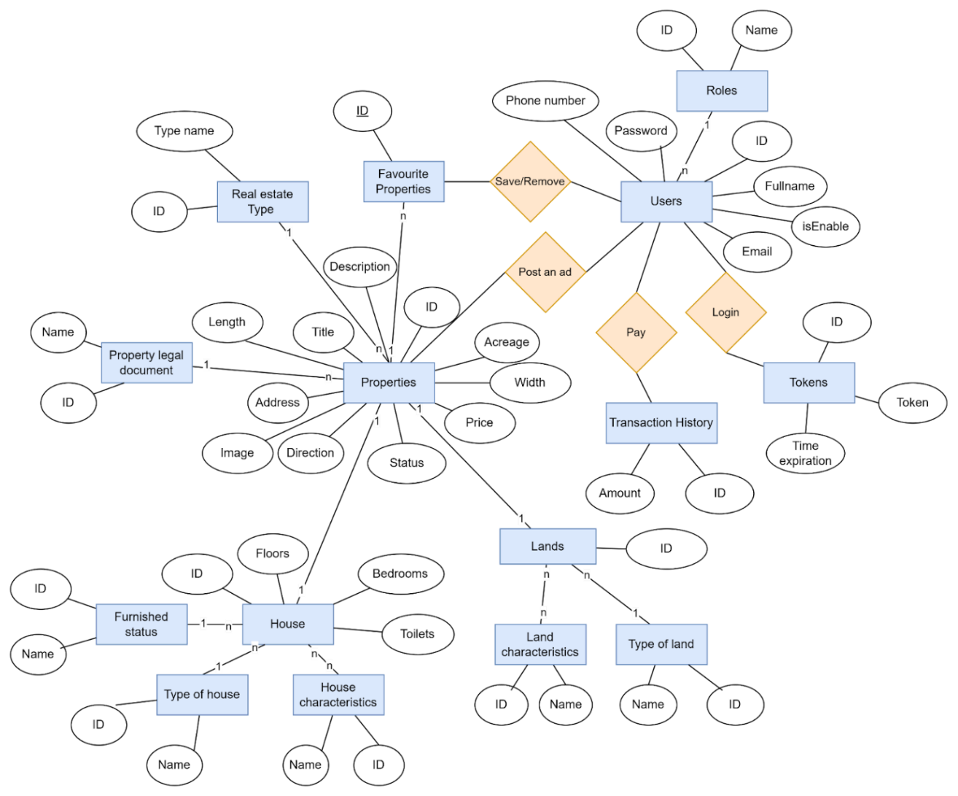

Figure . The ER entity relationship model

### Converting an implementation model into a system model

* Role table (roles)

Table . Describe role table attributes

|  |  |  |  |  |
| --- | --- | --- | --- | --- |
| Field Name | Data Type | Required | Constraint | Description |
| role_id | Integer | Not null | Primary Key | Code of permission |
| name | Enum | Not null |  | Name of permission |

* User table (users)

Table . Describe user table attributes

|  |  |  |  |  |
| --- | --- | --- | --- | --- |
| Field Name | Data Type | Required | Constraint | Description |
| user_id | Integer | Not null | Primary Key | Code of the user |
| role_id | Integer | Not null | Foreign Key | Permission |
| isEnable | Boolean | Not null |  | The user account is active or inactive |
| fullName | String | Not null |  | Full name of user |
| email | String | Not null |  | Email of the user |
| password | String | Not null |  | Password of the user (will be encrypted before entering the database) |
| phone | String | Not null |  | Phone number of the user |
| created_at | LocalDataTime |  |  |  |
| updated_ad | LocalDataTime |  |  |  |

* Token table (tokens)

Table . Describe the token table attributes

|  |  |  |  |  |
| --- | --- | --- | --- | --- |
| Field Name | Data Type | Required | Constraint | Description |
| token_id | Integer | Not null | Primary Key | Code of token |
| user_id | Integer | Not null | Foreign Key | User |
| token | String | Not null |  | A temporary or persistent string used to authenticate and authorize a user or system |
| created_at | LocalDataTime |  |  |  |
| updated_ad | LocalDataTime |  |  |  |

* Transaction history table

Table . Describe the transaction histories table attributes

|  |  |  |  |  |
| --- | --- | --- | --- | --- |
| Field Name | Data Type | Required | Constraint | Description |
| transaction_id | Integer | Not null | Primary Key | Code of token |
| user_id | Integer | Not null | Foreign Key | User |
| amount | Number | Not null |  | Amount paid |
| created_at | LocalDataTime |  |  |  |
| updated_ad | LocalDataTime |  |  |  |

* Favourite property table (favourite_properties)

Table . Describe the favourite properties of table attributes

|  |  |  |  |  |
| --- | --- | --- | --- | --- |
| Field Name | Data Type | Required | Constraint | Description |
| favourite_ property_id | Integer | Not null | Primary Key | Code of favourite property |
| user_id | Integer | Not null | Foreign Key | User |
| property_id | Integer | Not null | Foreign Key | Property |
| created_at | LocalDataTime |  |  |  |

* Category table (categories)

Table . Describe the category table attributes

|  |  |  |  |  |
| --- | --- | --- | --- | --- |
| Field Name | Data Type | Required | Constraint | Description |
| category_id | Integer | Not null | Primary Key | Code of category |
| Name | String | Not null |  | Name of category |

* Property table (properties)

Table . Describe the property table attributes

|  |  |  |  |  |
| --- | --- | --- | --- | --- |
| Field Name | Data Type | Required | Constraint | Description |
| property_id | Integer | Not null | Primary Key | Code of Property |
| user_id | Integer | Not null | Foreign Key | User |
| category_id | Integer | Not null | Foreign Key | Type of property |
| property_legal _document_id | Integer | Not null | Foreign Key | Type of property legal document |
| status | Enum | Not null |  | Approved or canceled |
| title | String | Not null |  | The title appears at the top of the article |
| description | String | Not null |  | Detailed description of the article |
| region | String | Not null |  | Province name |
| district_name | String | Not null |  | District name |
| ward_name | String | Not null |  | Ward name |
| street_name | String | Not null |  | Street name |
| longitude | Number | Not null |  | Coordinates |
| latitude | Number | Not null |  |
| direction | Number | Not null |  | Main direction of real estate |
| area | Number | Not null |  |  |
| length | Number | Not null |  |  |
| width | Number | Not null |  |  |
| images | String | Not null |  | Contains image links |
| price | Number | Not null |  |  |
| created_at | LocalDataTime |  |  |  |
| updated_ad | LocalDataTime |  |  |  |

* House table (houses)

Table . Describe the house table attributes

|  |  |  |  |  |
| --- | --- | --- | --- | --- |
| Field Name | Data Type | Required | Constraint | Description |
| house_id | Integer | Not null | Primary Key | Code of a house |
| property_id | Integer | Not null | Foreign Key | Code of a property |
| furnished_ status_id | Integer | Not null | Foreign Key | Interior condition |
| house_ type_id | Integer | Not null | Foreign Key | Type of house |
| floors | Integer | Not null |  |  |
| bedrooms | Integer | Not null |  |  |
| toilets | Integer | Not null |  |  |

* Furnished status table (furnished_status)

Table . Describe the furnished status table attributes

|  |  |  |  |  |
| --- | --- | --- | --- | --- |
| Field Name | Data Type | Required | Constraint | Description |
| furnished_ status_id | Integer | Not null | Primary Key | Code of a furnished status |
| name | String | Not null |  | Describe the condition of the interior |

* Type of house table (house_type)

Table . Describe the type of house table attributes

|  |  |  |  |  |
| --- | --- | --- | --- | --- |
| Field Name | Data Type | Required | Constraint | Description |
| house_ type_id | Integer | Not null | Primary Key | Code of a house type |
| name | String | Not null |  | House type description |

* House characteristics table (house_characteristics)

Table . Describe the house characteristics table attributes

|  |  |  |  |  |
| --- | --- | --- | --- | --- |
| Field Name | Data Type | Required | Constraint | Description |
| house_ characteristic_id | Integer | Not null | Primary Key | Code of a house  characteristics |
| name | String | Not null |  | House characteristics description |

* + Here, create an additional table (house_characteristic_mappings) to hold the characteristic keys of the house object.

Table . Describe the house characteristic mapping table attributes

|  |  |  |  |  |
| --- | --- | --- | --- | --- |
| Field Name | Data Type | Required | Constraint | Description |
| house_characteristic_ mapping_id | Integer | Not null | Primary Key | Code of a house  characteristic mapping |
| house_ characteristics_id | Integer | Not null | Foreign Key | House  characteristics |
| house_id | Integer | Not null | Foreign Key | House |

* Land table (lands)

Table . Describe the land table attributes

|  |  |  |  |  |
| --- | --- | --- | --- | --- |
| Field Name | Data Type | Required | Constraint | Description |
| land_id | Integer | Not null | Primary Key | Code of a house |
| property_id | Integer | Not null | Foreign Key | Code of a property |
| land_type_id | Integer | Not null | Foreign Key | Type of land |

* Type of land table (land_types)

Table . Describe the type of land table attributes

|  |  |  |  |  |
| --- | --- | --- | --- | --- |
| Field Name | Data Type | Required | Constraint | Description |
| land_type_id | Integer | Not null | Primary Key | Code of a land type |
| name | String | Not null |  | Land type description |

* Land characteristics table (land_characteristics)

Table . Describe the land characteristics table attributes

|  |  |  |  |  |  |
| --- | --- | --- | --- | --- | --- |
| Field Name | Data Type |  | Required | Constraint | Description |
| land _ characteristic_id | Integer |  | Not null | Primary Key | Code of a land  characteristics |
| name | String |  | Not null |  | Description of land characteristics |

* + Here, create an additional table (land_characteristic_mappings) to hold the characteristic keys of the land object.

Table . Describe the land characteristic mapping table attributes

|  |  |  |  |  |
| --- | --- | --- | --- | --- |
| Field Name | Data Type | Required | Constraint | Description |
| land _characteristic_ mapping_id | Integer | Not null | Primary Key | Code of land  characteristic mapping |
| land _ characteristics_id | Integer | Not null | Foreign Key | Land  characteristics |
| house_id | Integer | Not null | Foreign Key | Land |

### Database schema

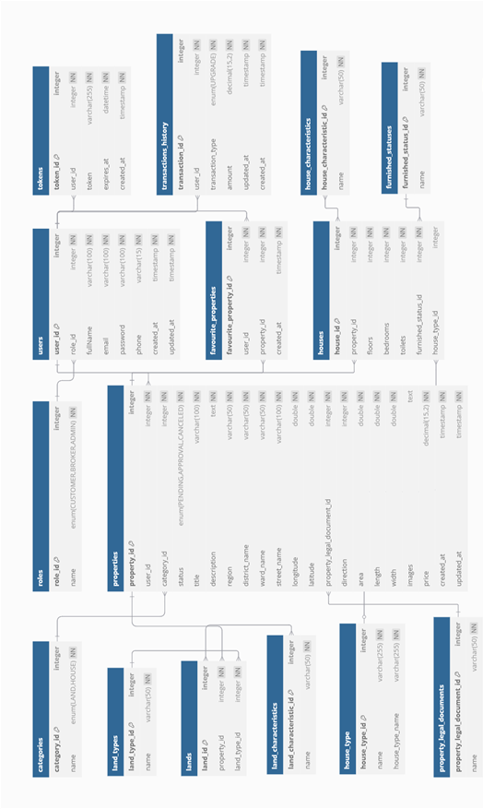

Figure . Relational Model

## Real estate prediction system development

* The problem of predicting real estate prices will be divided into two types:
  + Real estate valuation: Users will provide information related to the land or the house they want to sell or buy for the system to evaluate.
  + Real estate price forecast: The system will predict the price shortly after a certain area is given by users at the same level.
* Common processing steps of the two models

### Data crawling

* Collect data from the *nhatot.com* website and have a “RawData.csv” file with 33270 samples.
  + This dataset contains two property types: house and land. For entries where the property type is land, the numerical values for **Rooms, Toilets, Floors** and **Furnishing Sell** are set to 0.

### Data cleaning

* Validate values: Check if there are any values less than 0

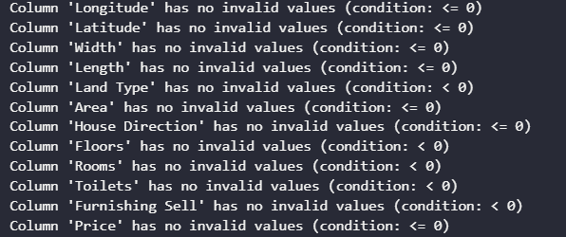

Figure . Statistics to check features with values less than 0

#### Handling missing

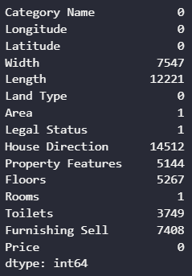

Figure . Statistics of missing values

* Since many missing values can significantly alter the overall data distribution and characteristics when inputted, I decided to remove all samples with three or more missing features to preserve the integrity of the dataset.

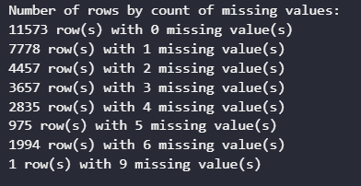

Figure . Distribution of rows based on the number of missing values

* Confirming that the area data is complete, we proceed to handle missing values for **width** and **length** as follows:
  + If either width or length is missing, we estimate the missing value using the area calculation formula (Area = Width × Length).
  + If both width and length are missing, we assign a default value of 5 meters for both width and length.

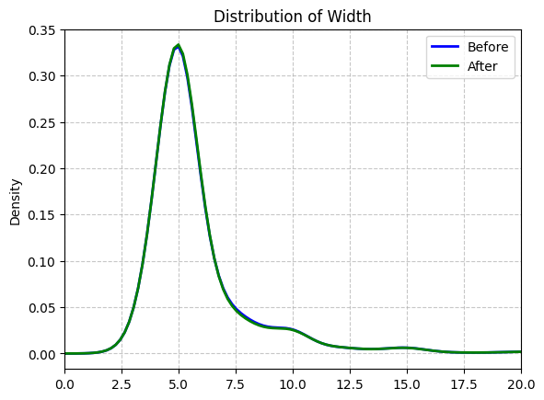

Figure . Width distribution before and after preprocessing

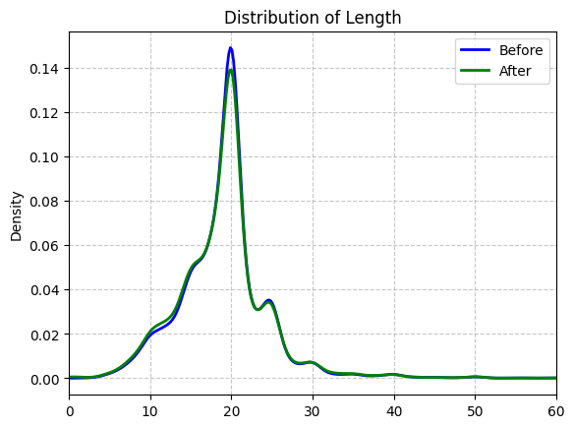

Figure . Length distribution before and after preprocessing

* For the **direction** feature, missing values are imputed using a random sampling method.

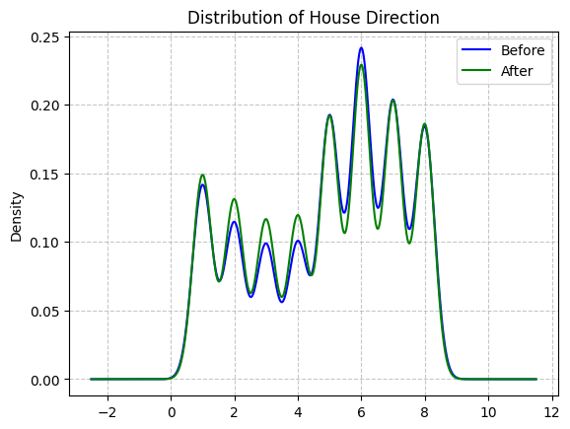

Figure . Direction distribution before and after preprocessing

* Regarding the **property features** variable:
  + If the land type is residential land, the default value for property features is set to 3 (partly residential land).
  + Otherwise, it is set to 2 (non-residential land).

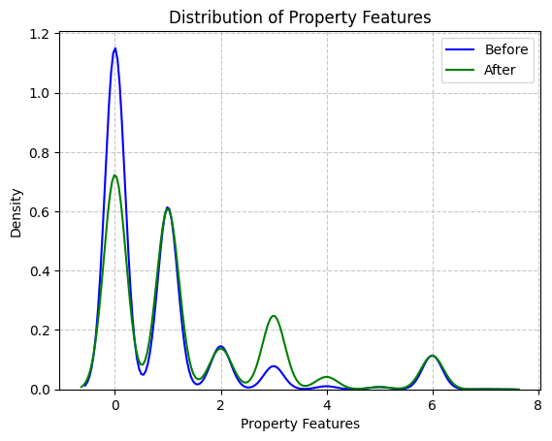

Figure . Property features distribution before and after preprocessing

* As for the **floor features**, based on common housing layouts:
  + The ground floor typically contains 1 bedroom.
  + Each upper floor usually has 2 bedrooms.

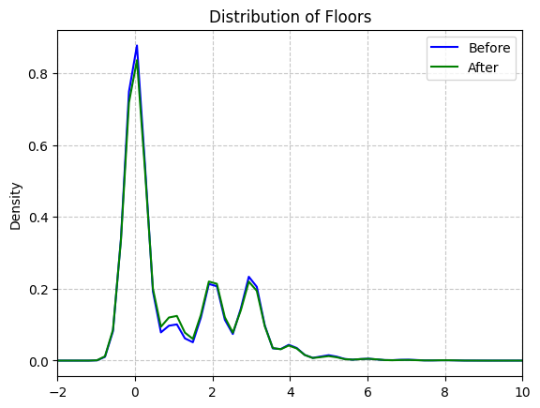

Figure . Floor distribution before and after preprocessing

* The number of **toilets** is assumed to be equal to the number of floors.

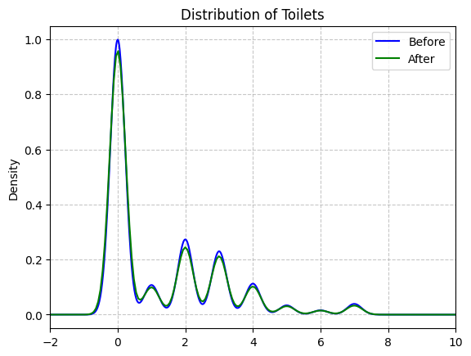

Figure . Toilet distribution before and after preprocessing

* Finally, for the **furnishing sell** feature, missing values are also imputed using a random sampling method.

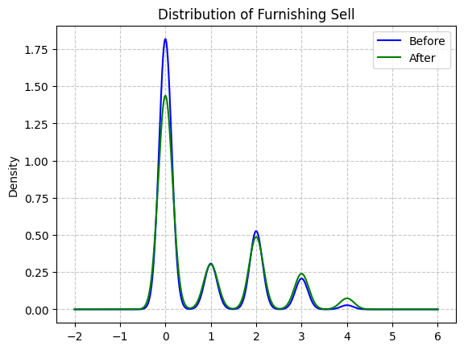

Figure . Furnishing sales distribution before and after preprocessing

**Notes**: Most plots show that data cleaning preserved the original distribution shape, indicating that the overall data structure remained largely intact. In the “Distribution of Length” and “Distribution of Width” plots, cleaning effectively removed some outliers in the right tail. Key distribution peaks were maintained across most features, suggesting minimal impact on the core data.

However, in the “Distribution of Property Features” plot, there is a noticeable difference between the before (blue) and after (green) curves, especially in the 0–1 range, which may indicate a loss of important information. Similarly, in the “Distribution of Furnishing Sell” plot, the main peak’s density decreased after cleaning, potentially affecting analyses involving this feature.

#### Handling outliers

* These charts reveal several serious issues with the data distribution, as most variables are heavily skewed and concentrated within a very narrow range of values.

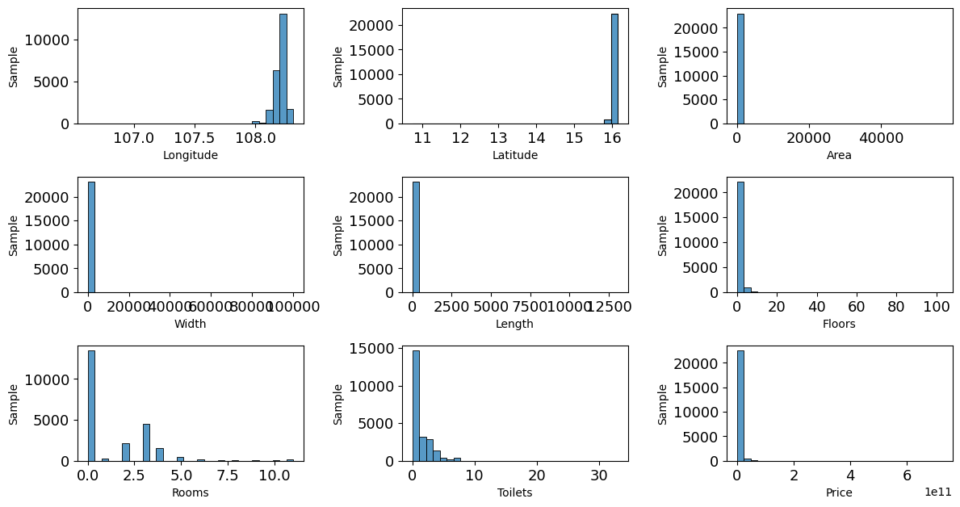

Figure . Histogram plots of feature distributions

* To improve data quality, we applied outlier removal techniques to variables with high skewness. This helped reduce the impact of extreme values and enhanced the reliability of subsequent analyses and modeling

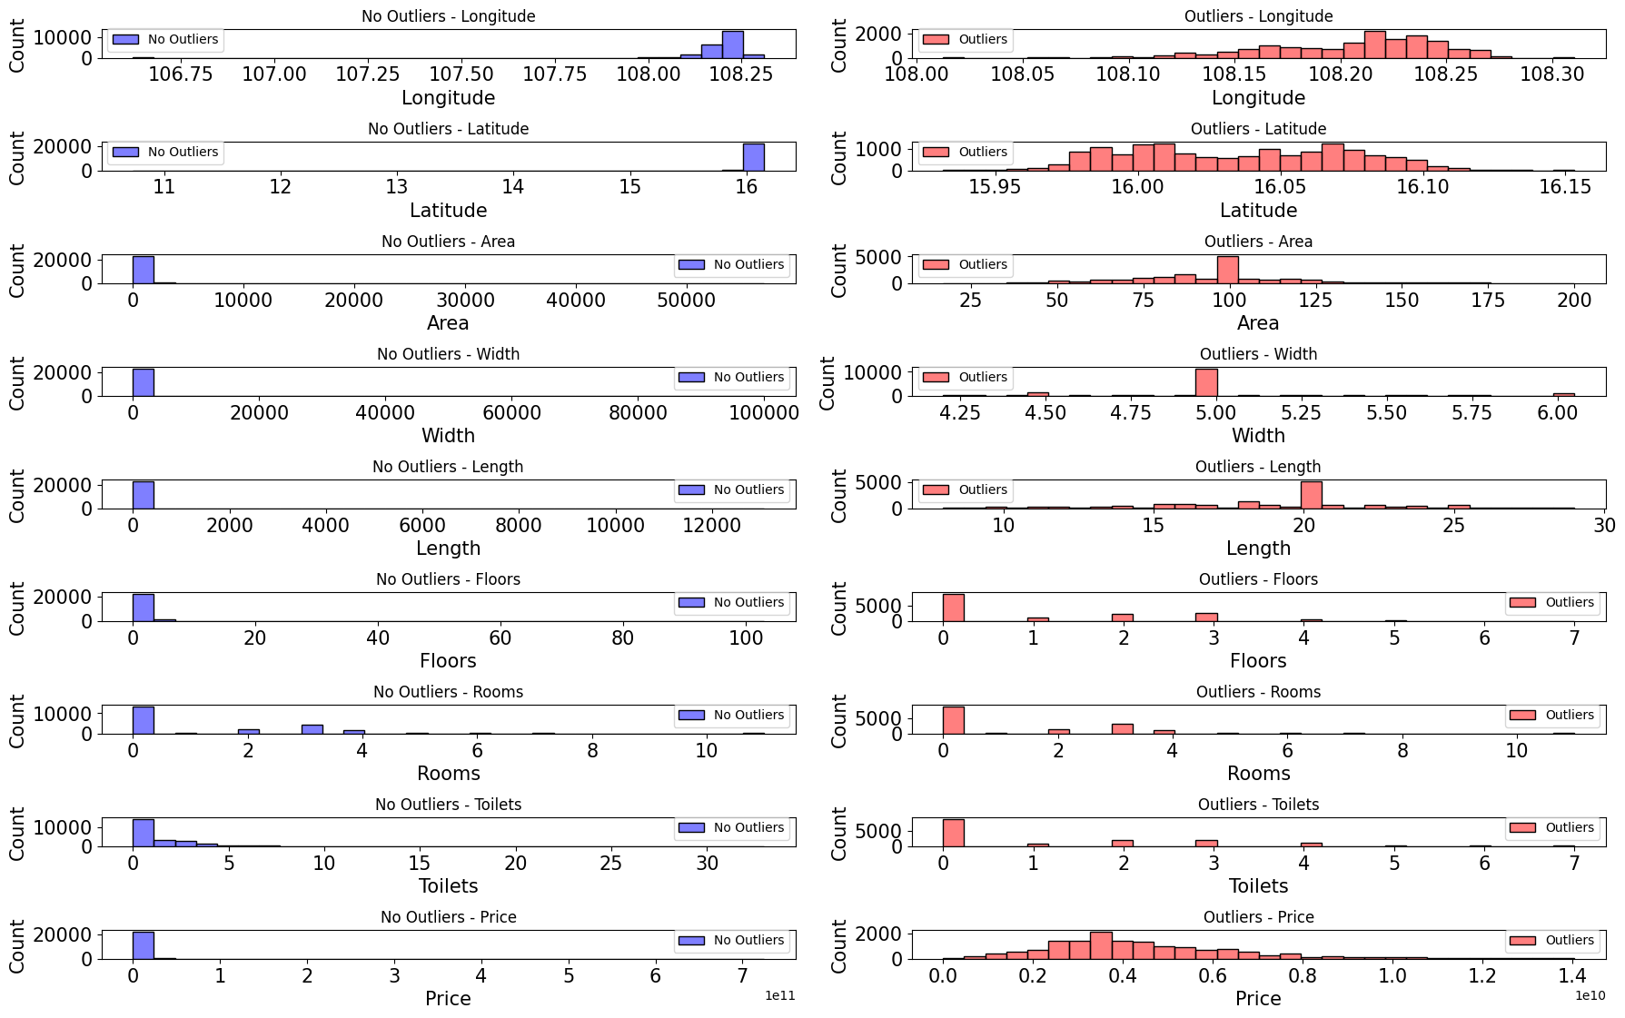

Figure . Visual comparison of outlier impact on feature distributions

* The process returns a cleaned dataset containing the following fields and is exported as “Cleandata.csv”:

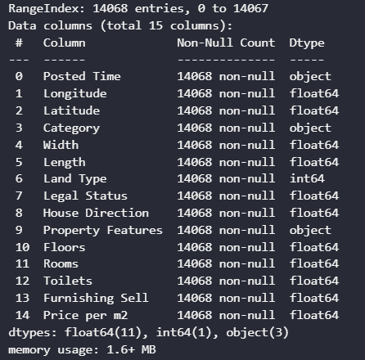

Figure . Real estate price forecast features

### **Data engineering**

* Feature Transformation:
  + First, one-hot encoding is applied to categorical variables such as **property category, land type, direction, furnishing status and district.**
  + For numerical features, various normalization techniques (e.g., Z-score, log, sqrt, min-max, arsinh) are tested. The most effective method is selected based on distribution analysis.
  + The result is a transformed dataset exported as “TransformedData.csv”.

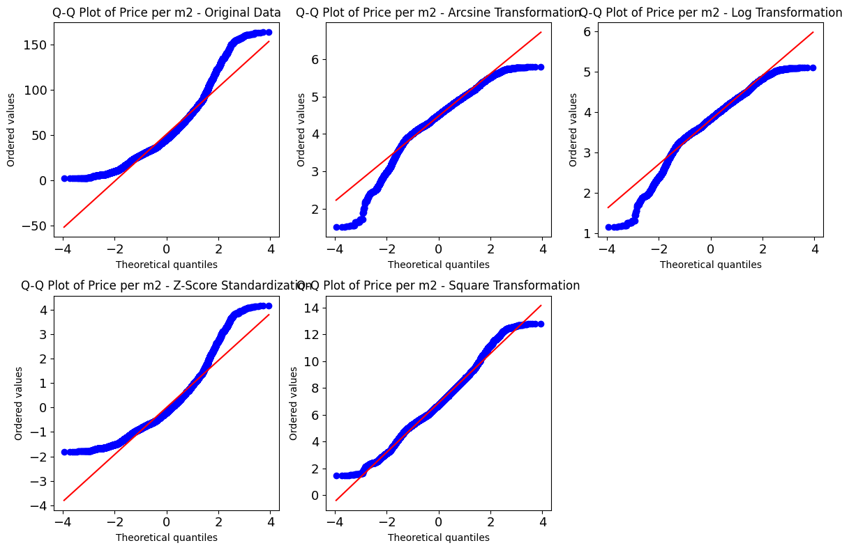

Figure . Comparison of Q-Q Plots of **Price per m²** across different transformation methods

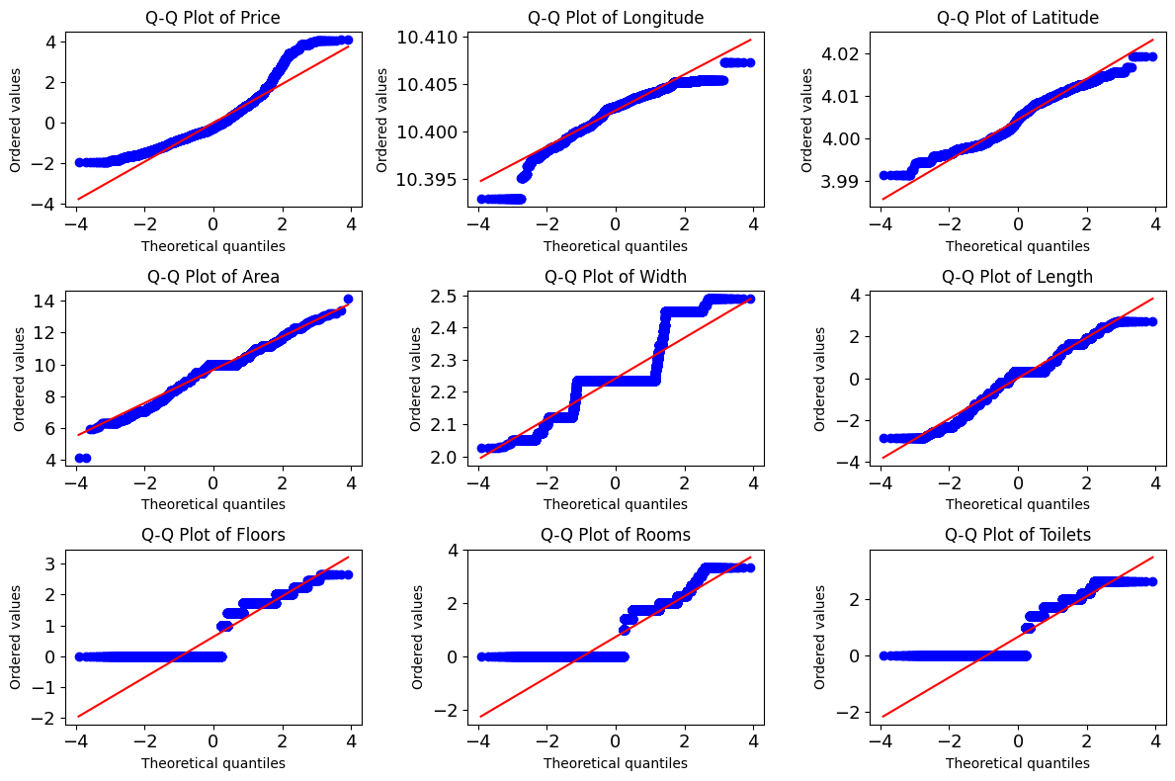

Figure . Q-Q Plots after optimal normalization per feature

* Feature Selection:
  + Observing the relationships between the coordinates (Longitude, Latitude), area and width with the target variable (Price), it was noted that these features have a slight correlation with the target.

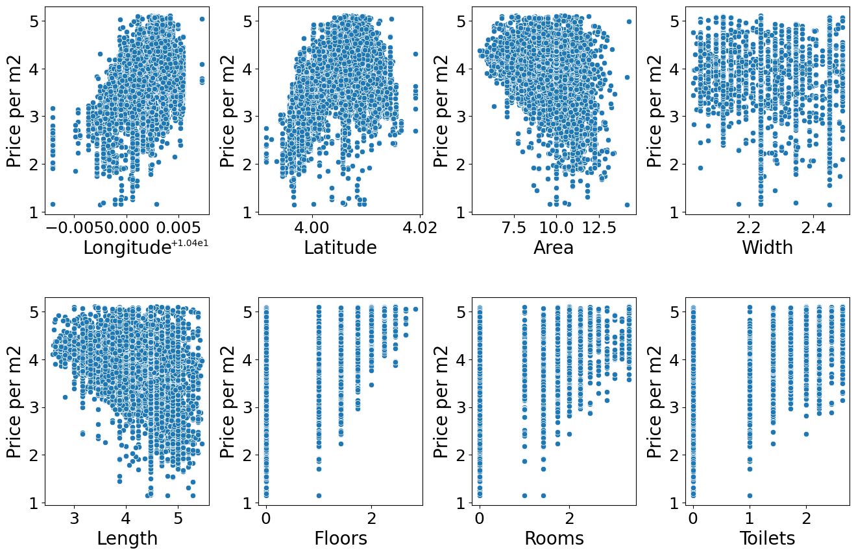

Figure . Scatter plot of features vs. **Price**

* + **SelectKBest** was used to rank the features based on their correlation with the target, with **Longitude** and **Latitude** being the most influential.

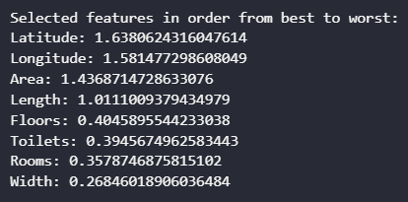

Figure . Selected features in order from best to worst.

* + The **RFECV** method was then applied, selecting the optimal number of features, which is 8 in this case. The best set of features for predicting the target variable includes **Longitude, Latitude, Area, Length, Floors, Rooms** and **Toilets**.

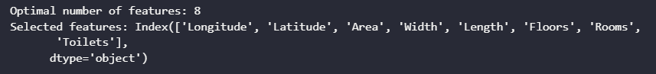

Figure . Optimal number of features

* + The plot of the **RFECV** shows the relationship between the number of selected features and the mean test accuracy.

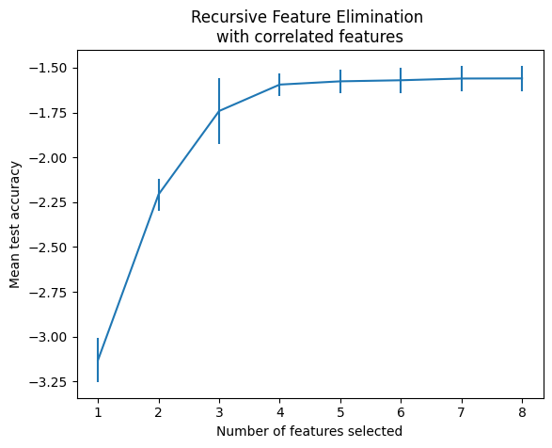

Figure . Recursive Feature Elimination with Correlated Features

### Real estate price prediction model

* To handle time-based patterns, we extracted temporal features from the **Posted Time** field:
* **year, month, day, day of week** and **quarter**: These features retain temporal information, helping the model better understand when each data point occurred.
* The dataset was split into two parts:
  + 80% for training (13965 samples)
  + 20% for testing (3492 samples)
* Three forecasting models were applied for comparison: XGBoost Regressor, LightGBM Regressor, Facebook Prophet, Ridge Regression and Random Forest Regression.
* The evaluation metrics for the Random Forest Regression model that achieved the best performance is presented below:

Table . Evaluation metrics table for the real estate price prediction models

|  |  |  |
| --- | --- | --- |
|  | Train set | Test set |
| MSE | 0.05277 | 0.38099 |
| RMSE | 0.22973 | 0.61724 |
| R² | 98.44% | 89.33% |

* + The results showed high performance with low overfitting: The model achieved R² = 98.44% (train) and 89.33% (test), indicating strong explanatory power. The 9.11% gap suggests mild overfitting, with test RMSE remaining within acceptable limits.

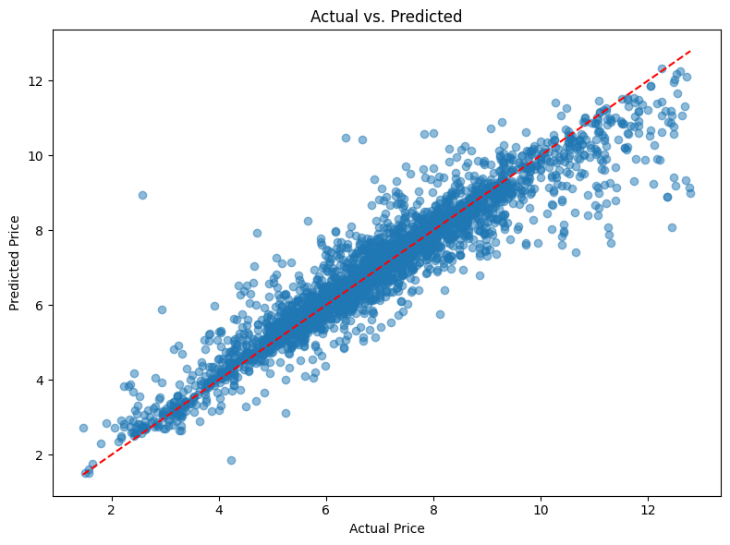

Figure . Scatter plot of actual vs. predicted real estate prices per m2 on the test set

* + The “Actual vs. Predicted” plot shows that predictions follow the regression line closely, meaning they are very close to the actual values. However, a slightly wider spread is observed in the higher price range (10.0–12.0), which should be considered when applying the model to high-end properties.

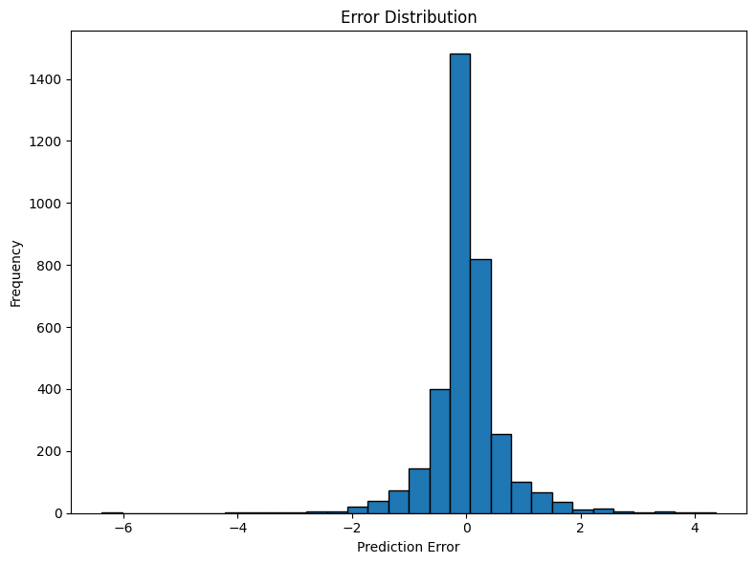

Figure . Error distribution

* + Normal error distribution without bias: The error histogram forms a bell-shaped curve centered around 0, indicating no systematic prediction bias.

## Harmful content preventing

### NSFW image classification model

* In this project, I integrated the *NudeNetv2* [16] model to detect and classify sexually explicit content in images. I utilized the pre-trained “classifier_model.onnx” for efficient inference.
* The model categorizes content into two classes:
  + safe – The image/video is not sexually explicit
  + unsafe – The image/video contains nudity or explicit content
* I cloned the repository and used the available ONNX version of the classifier to make predictions about image data.
* This classification component plays a crucial role in automatically filtering out inappropriate content, enhancing the safety and compliance of our platform.

### Toxic content detection model

* The *naot97/vietnamese-toxicity-detection_1* [17] model is a deep learning model trained to detect toxic content in Vietnamese. It is based on the T5 architecture and published on the Hugging Face platform.
* Key files:
  + **config.json**: Contains model configuration such as the number of layers, attention heads, etc.
  + **pytorch_model.bin**: Pretrained T5 weights in PyTorch format.
  + **tokenizer.json**: Tokenizer configuration, including:
    - Normalizer: Cleans and standardizes text.
    - Pre-tokenizer: Uses metaspace with “▁” as replacement.
    - Vocabulary: Over 32,000 tokens.
    - Post-processor: Appends special tokens such as </s>.
  + **vocab.json**: Maps tokens to indices.
  + **special_tokens_map.json**: Defines special tokens like <pad>, <unk>, etc.
  + **tokenizer_config.json**: Additional tokenizer settings.
* Since Java does not support original PyTorch models natively, we converted the model to ONNX format to run it efficiently in a Spring Boot backend using AI libraries like DJL or ONNX Runtime, etc. I have converted the model into ONNX format.
* Input normalization and model output:
  + Input text is preprocessed according to rules defined in “tokenizer.json”, ensuring consistency with the training pipeline.
  + The model returns an array with two elements:
    - The first value represents the probability of non-toxic content.
    - The second value represents the probability of toxic content.

## Deployment

### Deploying the backend application on AWS

Deploying an application is a crucial step in the entire software development lifecycle. During the deployment of the backend application on AWS cloud, I used a combination of services and tools including Amazon S3, Amazon RDS, Amazon EC2, along with management tools such as WinSCP, PuTTY, and MySQL Workbench.

#### Creating a file and image storage

* Amazon S3 is used as a static data storage (files, images, videos, documents, etc.).
* Steps:
  + Access the Amazon S3 service and create a new bucket.
  + Name the bucket uniquely and select the appropriate region.
  + Configure access permissions and IAM policies.
  + Create IAM Access Keys (Access Key ID and Secret Access Key) for backend integration. Using these keys, the application can perform upload, download, and delete operations on S3.

#### Creating a MySQL database with Amazon RDS

* Amazon RDS facilitates easy deployment, scaling, and management of databases without worrying about complex physical infrastructure. In this system, RDS is used to store user info, posts, and other backend-related data.
* Steps:
  + Access Amazon RDS and create a new database with MySQL engine.
  + Configure connection info: username, password, database name.
  + Network and connectivity:
    - Enable public access to allow external connections.
    - Configure VPC, subnet groups, and security groups to open port 3306 for trusted IPs or the entire network in dev.
  + After creation, use the endpoint, port, username and password to:
    - Connect via MySQL Workbench.
    - Configure backend connection to the database.

#### Creating an EC2 instance to deploy the backend application

* Amazon EC2 provides virtual machines running 24/7 on the cloud. This is where the Java backend application (packaged as .jar or .war) will be deployed and run, serving APIs for frontend or mobile apps.
* Steps:
  + Access EC2 to a new instance and choose an Amazon Machine Image
  + Configuration
    - Choose instance type: This defines the hardware configuration of my EC2 instance.
    - Create a key pair and save it: Used to securely log in to my EC2 instance via SSH.
  + Set up a security group:
    - Open port 22 (SSH): Allows remote access to the EC2 instance via SSH.
    - Open port 8080 (or other backend port): Enables external users to access my API or web interface.
  + Record important information
    - Public IPv4 address: The public IP address is used to access the EC2 server from outside.
    - Public DNS (IPv4): A temporary domain name that points to my EC2 instance's public IP.
* Supporting tools during deployment
  + **WinSCP**: A GUI tool to transfer files over SFTP. Used to upload the .jar file from the local machine to EC2. Connection setup includes EC2 IP, user (ec2-user), and *.ppk* key file.
  + **PuTTY**: An SSH terminal software to connect from a local machine to an EC2 server via port 22. After logging in, run “*java -jar my-app.jar”* to start the Spring Boot application. Once running successfully, I can access the API via the Public IPv4 DNS and instance port.

### Deploying the frontend application on Vercel

Deploying the frontend with Vercel is simple and fast. Just log in with a GitHub account, import the repository containing the frontend source code, and Vercel will automatically detect the framework, configure, and deploy the application.

## Chapter conclusion

This chapter provides the reader with an overview of the real estate business operations, offering insights into the key activities and processes involved in the industry. It also includes an analysis and design of the system architecture, along with a detailed discussion of the database model.

Additionally, the chapter focuses on the development of a price support system, which aims to assist buyers by offering pricing assistance and making real estate transactions more accessible.

The chapter also briefly explains deploying the backend on AWS and the frontend on Vercel, ensuring the application runs smoothly and is easily accessible online.

# IMPLEMENTATION AND RESULTS EVALUATION

## Description of achieved functionalities

### Customer-facing functionality

* **Log in**

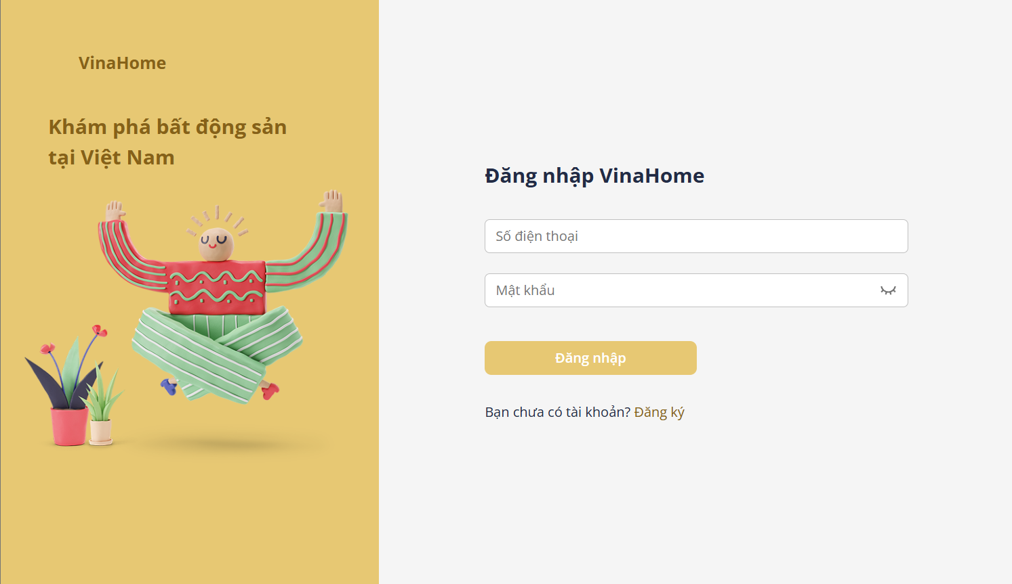

Figure . Login interface

* + The system provides a login page for users to enter their phone number and password. The system will verify the entered credentials against the system's user database.
  + If the account is not found in the system or is found but the password does not match, the system will display an error message to the user.
  + If the login is successful, the system will check the assigned role and redirect the user to the main screen of the application.

Table . Login function specification

|  |  |  |  |
| --- | --- | --- | --- |
| **Interface** | Login | | |
| **Description** | Displays the login page | | |
| **Access** | Users click the “Đăng nhập” button located on the header to access the login page. | | |
| Interface Contents | | | |
| **Item** | **Type** | **Description** | |
| Số điên thoại | Input | Enter phone number | |
| Mật khẩu | Input | Enter account password | |
| Đăng nhập | Button | Log in and access the website | |
| Đăng ký | Button | Register if the user has no account | |
| **Actions** | | | |
| **Name** | **Description** | **Success** | **Failure** |
| Log in | User enters phone number and password | Check user role: if the role is Customer or Broker, redirect to the homepage; if the role is Admin, redirect to the management page. | Invalid username will display the message “Tài khoản không tồn tại”. Wrong password will display the message “Số điện thoại hoặc mật khẩu không đúng”. Locked account will display the message “Tài khoản của bạn đã bị khoá”. |
| Register | Create a new account if the user doesn't have one | Display the account registration page | Do not redirect to a new page. |

* **Sign up**

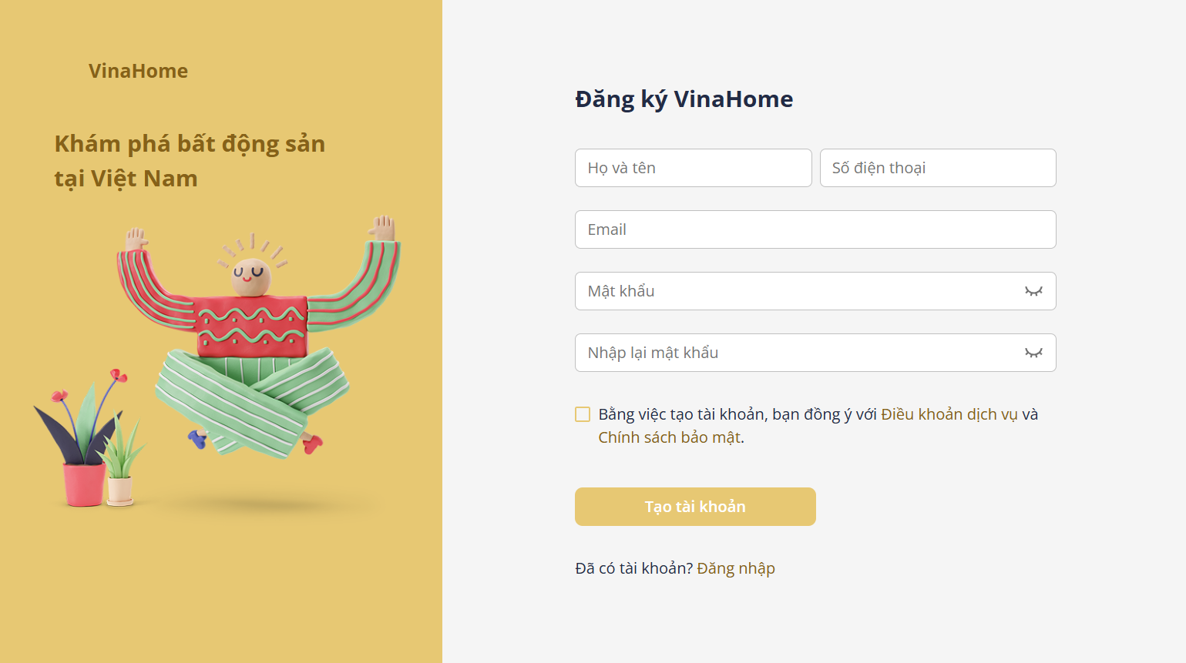

Figure . Register interface

* + When a user needs to log in but doesn't have an account, they will proceed to register for one.

Table . Register function specification

|  |  |  |  |
| --- | --- | --- | --- |
| **Interface** | Register | | |
| **Description** | Displays the register page | | |
| **Access** | The user accesses the login page and clicks the “Đăng ký” button. | | |
| Interface Contents | | | |
| **Item** | **Type** | **Description** | |
| Họ và tên | Input | Enter full name | |
| Số điên thoại | Input | Enter phone number | |
| Mật khẩu | Input | Enter account password | |
| Nhập lại mật khẩu | Input | Enter the account password again | |
| Đăng ký | Button | Register account | |
| Đồng ý với điều khoản | Checkbox | By creating an account, users agree to the terms of service and privacy policy. | |
| Đăng nhập | Button | Log in if the user has an account | |
| **Actions** | | | |
| **Name** | **Description** | **Success** | **Failure** |
| Đăng ký | The user enters personal information | The system redirects users to the login page and the data is stored in the database. | If any required information is missing or incorrectly formatted, a warning message is displayed.  If the re-entered password does not match the original password, a warning message is shown.  If the phone number or email already exists, the message “Số điện thoại/Email đã tồn tại” is displayed. |
| Đăng nhập | Log in if the user has one | Display the login page | Do not redirect to a new page. |

* **Post list**

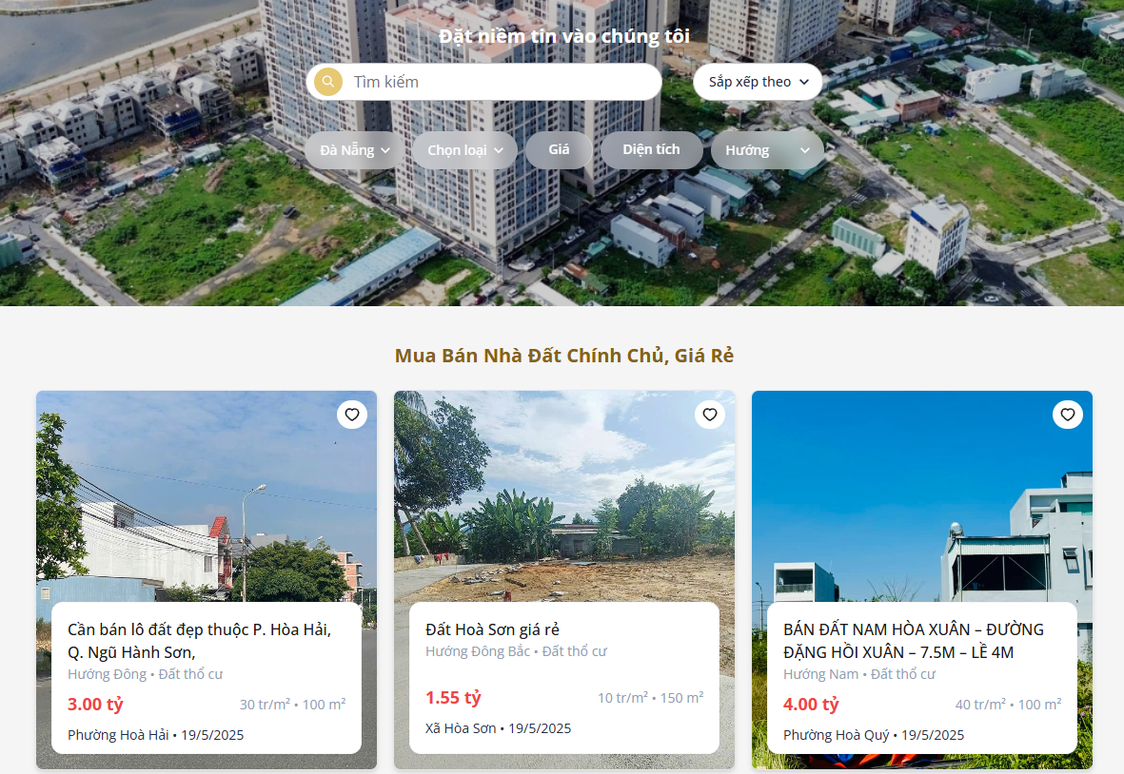

Figure . Post list interface

* + When a property type is selected, the filtering criteria are dynamically adjusted to match the characteristics of the chosen property category.

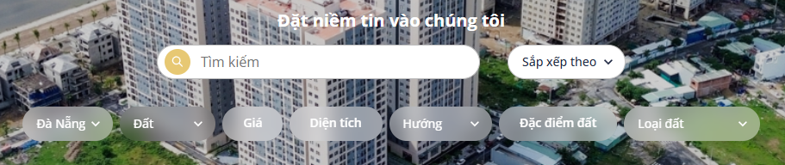

Figure . Search filter interface when selecting “Land” as the property type

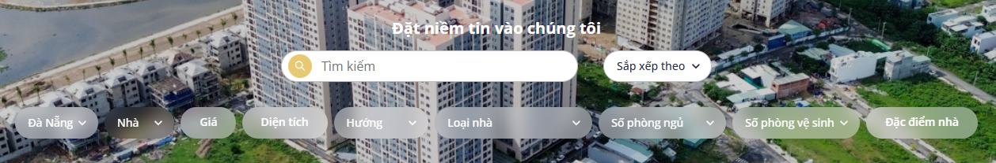

Figure . Search filter interface when selecting “House” as the property type

Table . Function specifications for the post list

|  |  |  |  |
| --- | --- | --- | --- |
| **Interface** | Property post list | | |
| **Description** | Displays the interface that shows property listings with search and filter functionality. | | |
| **Access** | The user selects “Bài đăng” in the header or applies any filter criteria to refine the property listings. | | |
| Interface Contents | | | |
| **Item** | **Type** | **Description** | |
| Tìm kiếm | Input | Search bar for property listings by title and description. | |
| Sắp xếp theo | Selectbox | Sort listings by different criteria | |
| Chọn loại | Selectbox | Select property category (land, house) | |
| Chọn tỉnh/thành | Selectbox | Select province/city | |
| Giá | RangeInput | Select the minimum and maximum price values. | |
| Diện tích | RangeInput | Select the minimum and maximum area in square meters. | |
| Hướng | Selectbox | Select property orientation | |
| Loại hình đất | Selectbox | Select land type | |
| Đặc điểm đất | RadioCheckbox | Select land characteristics | |
| Số phòng ngủ | Selectbox | Select the number of bedrooms | |
| Số phòng vệ sinh | Selectbox | Select the number of bathrooms | |
| Loại nhà | Selectbox | Select house type | |
| Đặc điểm nhà | RadioCheckbox | Select house characteristics | |
| Save post icon | Button | Save or remove a favourite post | |
| **Actions** | | | |
| **Name** | **Description** | **Success** | **Failure** |
| Apply filters | Enter keywords, select one or more filters. | Show listings matching the selected filters. | Display message: “Không tìm thấy bất động sản nào”. |
| View property details | Click a property listing card. | Redirect to the detail page showing full information. | Show message “Không tìm thấy bất động sản” if details cannot be loaded. |
| Save to favorites | Click heart icon on a listing | Listing added to favorites; heart icon turns red. | If the user is not logged in, the system shows “Vui lòng đăng nhập để lưu bài viết”. |

* **Post details**

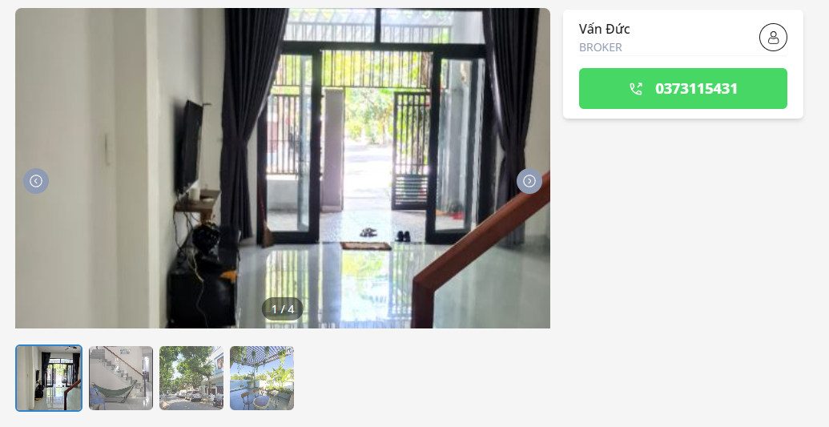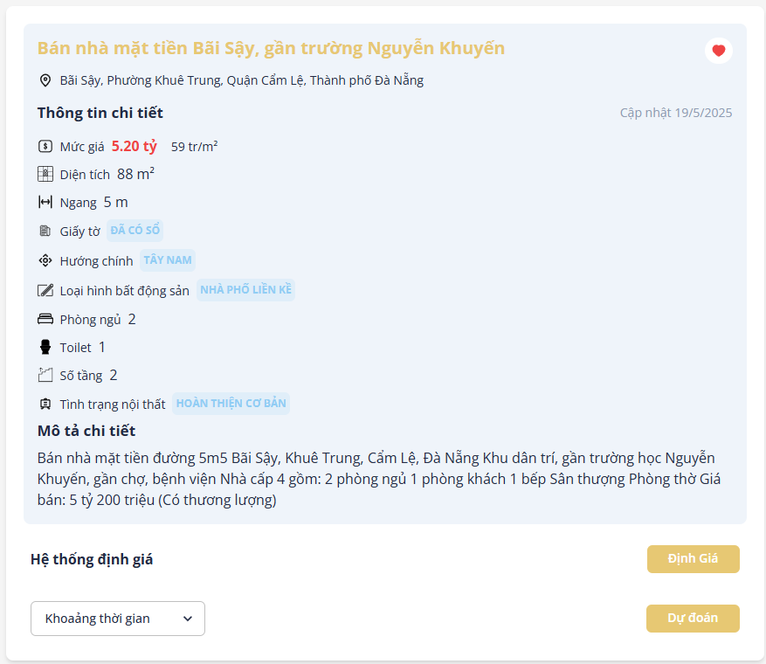

Figure . The post detail interface

* + This page displays detailed information about the property.
  + It also includes two additional features: price evaluation and future price forecasting. The future price forecasting feature is only available to users with upgraded accounts.
  + Below are the results of the property’s price evaluation and future price forecasting.

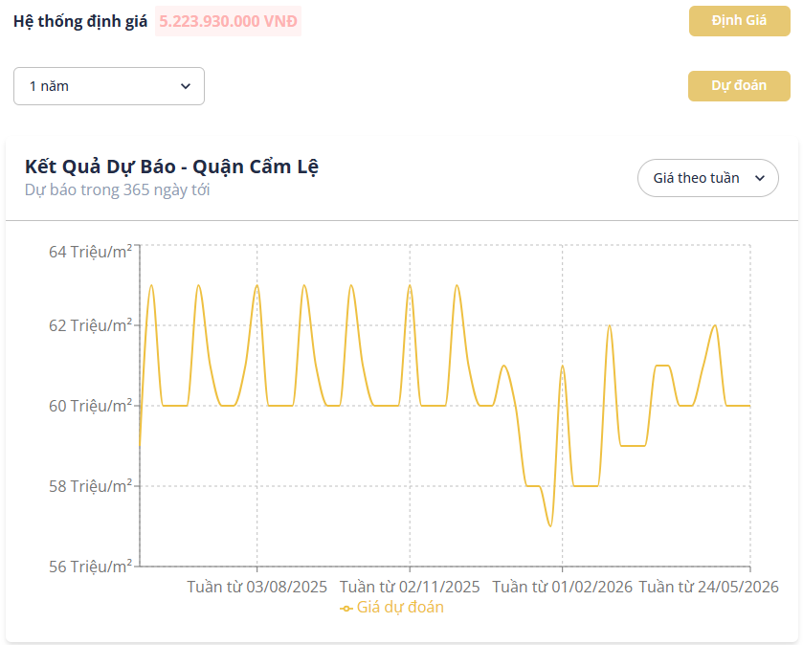

Figure . Result of real estate price predictions

Table . Function specifications for the post detail

|  |  |  |  |
| --- | --- | --- | --- |
| **Interface** | Detail real estate post | | |
| **Description** | Displays the interface that shows property listings with search and filter functionality. | | |
| **Access** | The user selects a property card in the post list or personal favourite post list | | |
| Interface Contents | | | |
| **Item** | **Type** | **Description** | |
| Arrow icons | Button | View the next or previous image | |
| Heart icon | Button | Add or remove from the favorites list | |
| Chọn thời gian | Selectbox | Select time duration | |
| Định giá | Button | Evaluating real estate price | |
| Dự đoán | Button | Forecasting real estate price | |
| **Actions** | | | |
| **Name** | **Description** | **Success** | **Failure** |
| View next/previous image | The user clicks the left or right arrow icon to view other images in the gallery. | The system displays the previous or next image smoothly | If the image cannot be loaded, the system displays an error placeholder |
| Add/remove favorite | The user clicks the heart icon to add or remove the property from favorites. | If logged in, the heart icon toggles, and the listing is added/removed from favorites | If the user is not logged in, the system shows “Vui lòng đăng nhập để lưu bài viết”. |
| Evaluate the property | The user clicks the “Định giá” button to estimate the property value by using ML. | The system returns an estimated price based on property features | If the evaluation fails, the system displays “Hệ thống định giá thất bại” |
| Forecast real estate price | The user chooses a time duration and clicks the “Dự đoán” button to forecast the property price by using ML. | The system returns the estimated price by time and displays it to the user. | If the evaluation fails, the system displays “Hệ thống dự đoán giá thất bại” |

* **Favorite posts**

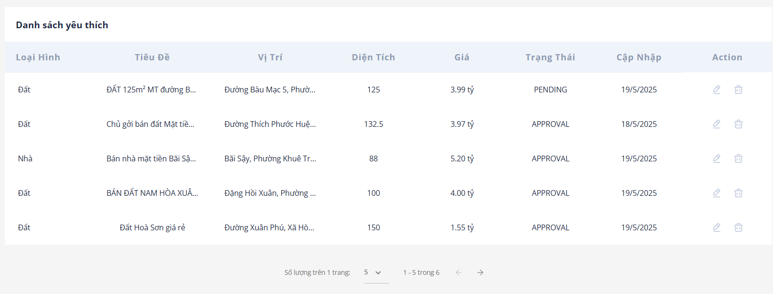

Figure . The love post detail interface

* + This page displays the list of posts the user has saved. When deleting a post, a confirmation warning message will appear.



Figure . Favorite post deletion confirmation popup

Table . Function specifications for the favourite post list

|  |  |  |  |
| --- | --- | --- | --- |
| **Interface** | My favourite post list | | |
| **Description** | Displays the interface that shows the favourite post list | | |
| **Access** | The user selects “Bài viết đã lưu” from the user menu in the header. | | |
| Interface Contents | | | |
| **Item** | **Type** | **Description** | |
| |  | | --- | | Bin icon | | Button | Remove the property from my favorite post list. | |
| |  | | --- | |  | | Pen icon | | | Button | Show detailed post | |
| **Actions** | | | |
| **Name** | **Description** | **Success** | **Failure** |
| View post details | The user clicks the pen icon to open the detailed view of a saved property listing | The system redirects to the post detail page | Show message “Không tìm thấy bài viết” if details cannot be loaded |
| Remove from favorites | The user clicks the bin icon; a confirmation message is shown and click “Đồng ý” button to remove | The property is removed from the list | The system displays “Xoá bài viết yêu thích thất bại” if the removal fails |

* **Add a new post**
  + To sell a property, users visit the posting page and select the type of property they wish to sell.



Figure . Property type select box

* + The system will then display input fields corresponding to the property type chosen by the user.

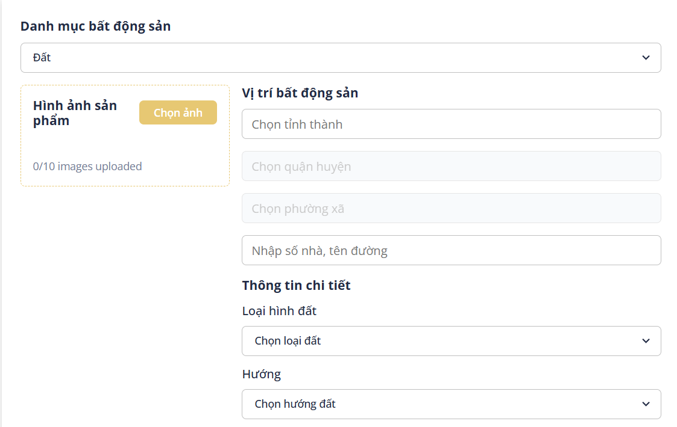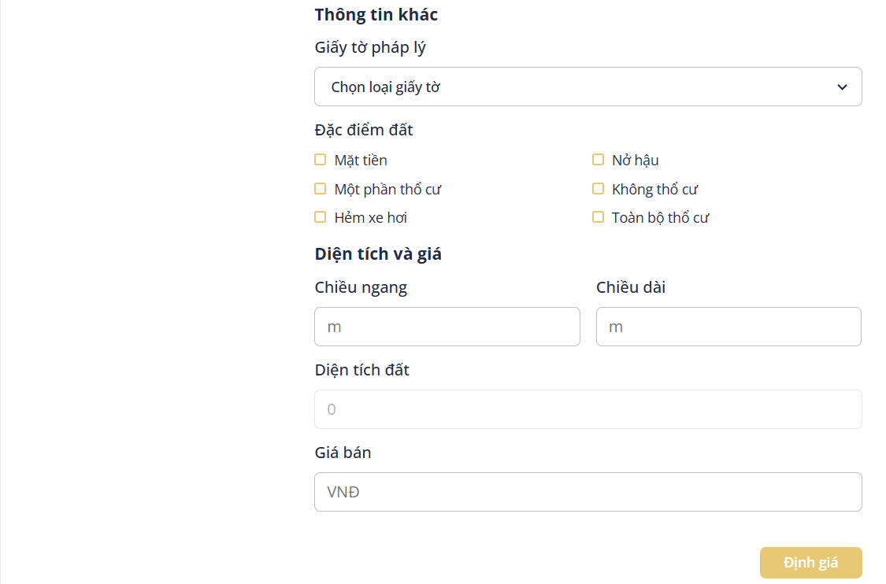 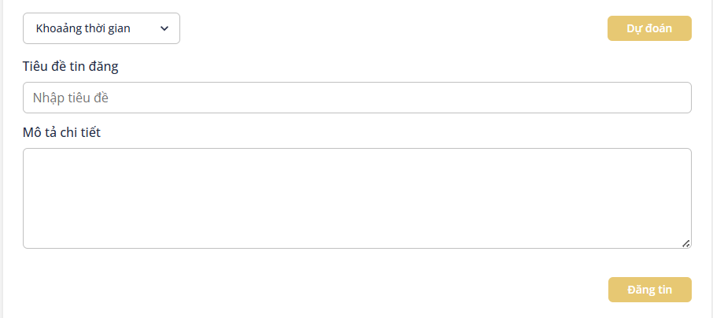

Figure . Add new post interface

* + This page also includes price evaluation and future price forecasting features, similar to those described on the property detail page.

Table . Add new post function specification

|  |  |  |  |
| --- | --- | --- | --- |
| **Interface** | Add property post | | |
| **Description** | Displays the interface that allows users to add new property information to the system. | | |
| **Access** | The user logs into the system and selects the “Đăng tin” in the header | | |
| Interface Contents | | | |
| **Item** | **Type** | **Description** | |
| Danh mục bất động sản | Selectbox | Select property category (land, house) | |
| Chọn tỉnh/thành | Selectbox | Select province/city | |
| Chọn quận/huyện | Selectbox | Select district | |
| Chọn xã/phường | Selectbox | Select ward | |
| Nhập số nhà, tên đường | Input | Enter the house number and street name | |
| Loại hình đất | Selectbox | Select land type | |
| Hướng | Selectbox | Select property orientation | |
| Giấy tờ pháp lý | Selectbox | Select legal document type | |
| Đặc điểm đất | RadioCheckbox | Select land | |
| Số tầng | Input | Enter the number of floors | |
| Số phòng ngủ | Selectbox | Select the number of bedrooms | |
| Số phòng vệ sinh | Selectbox | Select the number of bathrooms | |
| Tình trạng nội thất | Selectbox | Select the property's interior status | |
| Loại nhà | Selectbox | Select house type | |
| Đặc điểm nhà | RadioCheckbox | Select house characteristics | |
| Giá bán | Input | Enter the property selling price | |
| Tiêu đề tin đăng | Input | Enter post title | |
| Mô tả chi tiết | Textarea | Enter a detailed property description | |
| Khoảng thời gian | Selectbox | Select time duration | |
| Định giá | Button | Evaluating real estate price | |
| Dự đoán | Button | Forecasting real estate price | |
| Đăng tin | Button | Button to upload a post | |
| Hình ảnh bất động sản | Button | Button to upload property images | |
| **Actions** | | | |
| **Name** | **Description** | **Success** | **Failure** |
| Upload images | The user selects and uploads property images | The system displays uploaded images, counts the number of images. | If any image is detected to contain sensitive content, a warning message “Hình ảnh có chứa nội dung nhạy cảm” will be displayed and the post will be blocked from being submitted.  If the number of uploaded images exceeds the allowed limit, the system displays the message “Số lượng ảnh không vượt quá 10” |
| Evaluate property | The user fills in the required information and clicks the “Định giá” button | The system returns an estimated value based on the information provided. | If any required fields are missing or contain invalid data, the system displays appropriate error messages.  If the evaluation fails, the system displays “Hệ thống định giá thất bại” |
| Forecast real estate price | The user chooses a time duration and clicks the “Dự đoán” button to forecast the property price by using ML. | The system returns the estimated price by time and displays it to the user. | If any required fields are missing or contain invalid data, the system displays appropriate error messages.  If the evaluation fails, the system displays “Hệ thống dự đoán giá thất bại” |
| Upload post | The user completes the required information and clicks the “Đăng tin” button. | The system saves the property details to the database and redirects the user to the post listing page. If the post’s toxicity score is below 50, it will be marked as “**Approved**”. If the score is between 50 and 80, it will be marked as “**Pending**”. | If required fields are missing or invalid, the system shows relevant error messages.  If fewer than 3 images are uploaded, the system displays the message “Vui lòng tải lên ít nhất 3 hình ảnh”.  If the user has reached the maximum number of allowed listings (3 listings for regular users, 30 listings for brokers), the system displays “Tài khoản này đã đạt tối đa số lượng bài viết bất động sản.”.  If the post content is detected to be toxic, a warning message “Bài viết chứa nội dung nhạy cảm” will be displayed. |

* **Personal information**



Figure . Profile information interface

Table . Update profile function specification

|  |  |  |  |
| --- | --- | --- | --- |
| **Interface** | Profile information | | |
| **Description** | Displays the interface that shows personal information | | |
| **Access** | The user selects “Thông tin cá nhân” from the user menu in the header | | |
| Interface Contents | | | |
| **Item** | **Type** | **Description** | |
| Họ và tên | Input | Enter full name | |
| |  | | --- | |  |   Email | Input | Enter email | |
| Số điện thoại | Input | Enter phone number | |
| Lưu thay đổi | Button | Save the updated information | |
| **Actions** | | | |
| **Name** | **Description** | **Success** | **Failure** |
| Update profile | The user updates one or more fields and clicks “Lưu thay đổi” | The system saves the new information and shows a message “Cập nhập thông tin thành công” | The system displays “Cập nhật thông tin thất bại” if saving fails |

* **My posts**

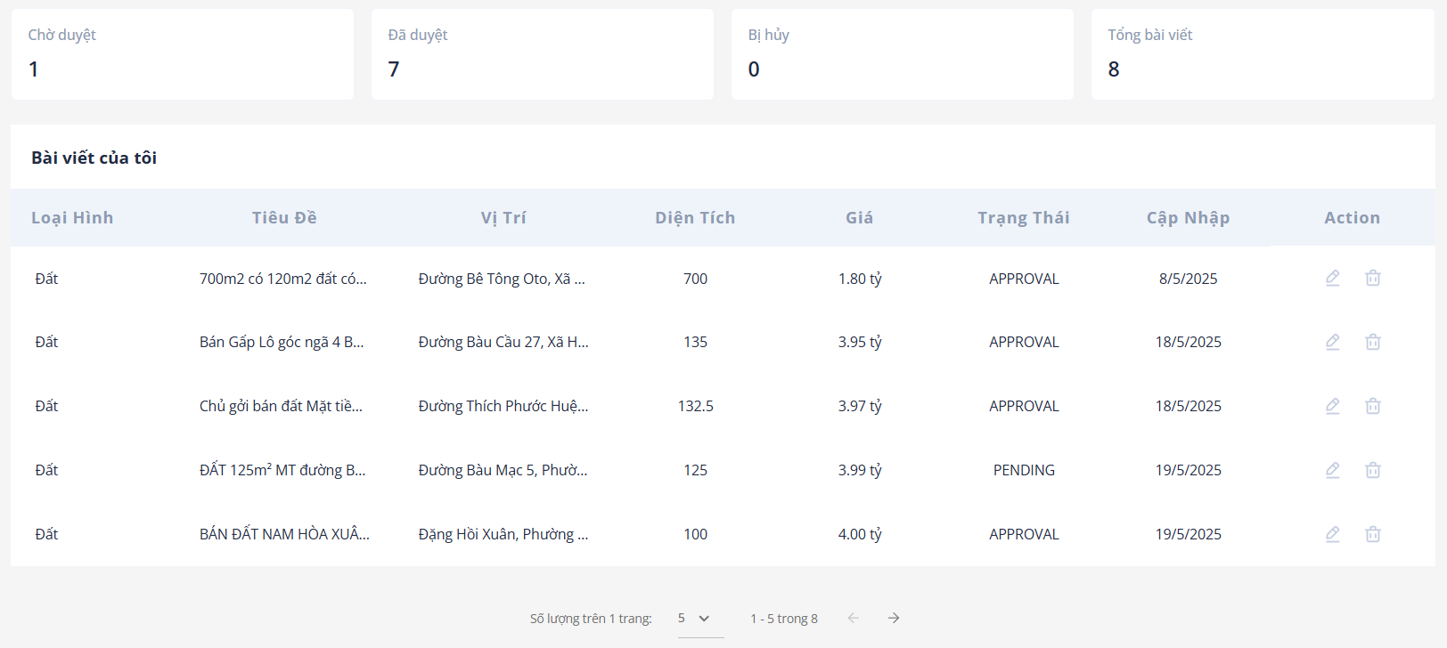

Figure . Personal post list interface

* + This page displays statistics of the posts published by the user. When the user attempts to delete a post, a confirmation warning message is shown.



Figure . Personal post deletion confirmation popup

Table . Function specifications for the personal post list

|  |  |  |  |
| --- | --- | --- | --- |
| **Interface** | The favourite post list | | |
| **Description** | Displays the interface that shows a list of personal posts | | |
| **Access** | The user selects “Bài viết của tôi” from the user menu in the header | | |
| Interface Contents | | | |
| **Item** | **Type** | **Description** | |
| |  | | --- | | Bin icon | | Button | Remove the property from the post list. | |
| |  | | --- | |  | | Pen icon | | | Button | Update the post information. | |
| **Actions** | | | |
| **Name** | **Description** | **Success** | **Failure** |
| Update post details | The user clicks the pen icon to open the edit view of a posted property | The system redirects to the property post editing page. | Show message “Không tìm thấy bài viết” if details cannot be loaded. |
| Remove from favorites | The user clicks the bin icon; a confirmation message is shown and clicks the “Đồng ý” button to remove | The property is removed from the list. | The system displays “Xoá bài viết thất bại” if the removal fails |

* **Account upgrade**

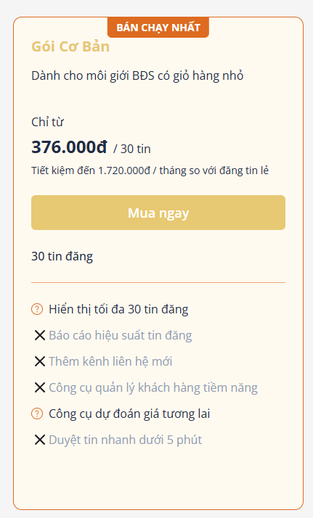

Figure . Upgrade account interface

* + When clicking the “Mua ngay” button, the user is redirected to the online payment page via VNPay, as shown below.

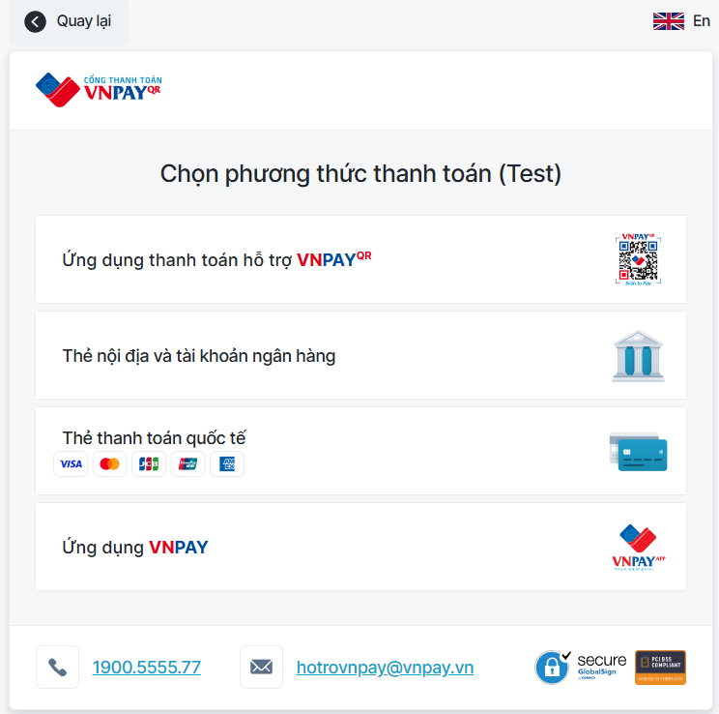

Figure . VNPay online payment gateway interface

Table . Function specifications for upgrading the account

|  |  |  |  |
| --- | --- | --- | --- |
| **Interface** | Upgrade account | | |
| **Description** | Displays the interface that shows the list of upgrade account packages | | |
| **Access** | The user selects “Nâng cấp” from the user menu in the header. | | |
| Interface Contents | | | |
| **Item** | **Type** | **Description** | |
| Mua ngay | Button | Open the online payment gateway | |
| **Actions** | | | |
| **Name** | **Description** | **Success** | **Failure** |
| Upgrade account | The user selects a subscription package and proceeds to pay via VNPAY | The account is upgraded to a broker account, a transaction record is created, and the system redirects to the transaction history page | If the user is not logged in, they are redirected to the login page.  If the selected package is lower than or equal to the current account level, the system displays the message “Tài khoản của bạn đã được nâng cấp lên gói vừa chọn hoặc cao hơn” |

* **Transaction history**

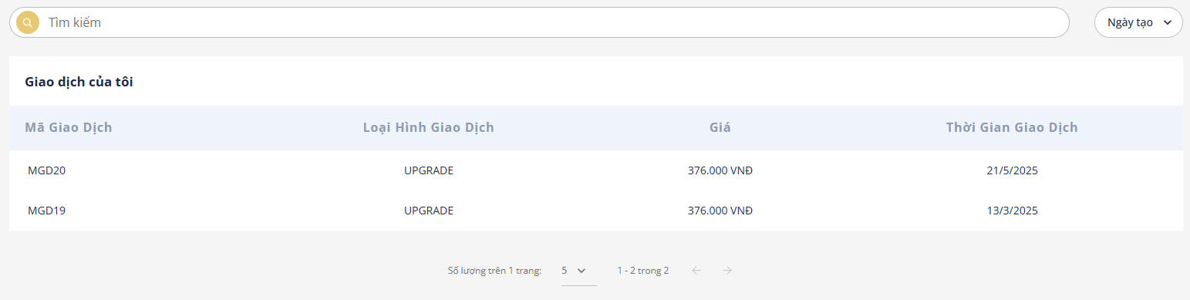

Figure . Transaction history interface

Table . Function specifications for showing transaction history

|  |  |  |  |
| --- | --- | --- | --- |
| **Interface** | Transaction history | | |
| **Description** | Displays the interface that shows the list of transactions | | |
| **Access** | The user selects “Lịch sử giao dịch” from the user menu in the header. | | |
| Interface Contents | | | |
| **Item** | **Type** | **Description** | |
| Sắp xếp theo | Selectbox | Select sorting criteria for the listings | |
| **Actions** | | | |
| **Name** | **Description** | **Success** | **Failure** |
| Sort listings | The user selects a sorting option from the dropdown | The system reorders the transaction listings based on the selected criteria | If sorting fails, the listing order remains unchanged and an error message is displayed |

### Admin-facing functionality

* Moderate posts

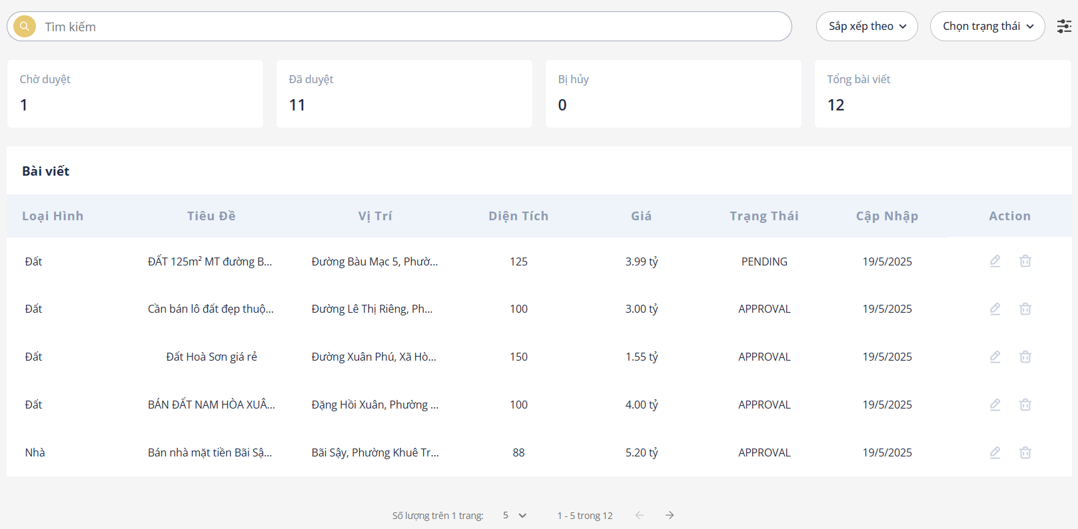

Figure . Post list interface

* + When the administrator clicks the edit button, the detailed information of the post will be displayed for moderation, as shown in the image below.

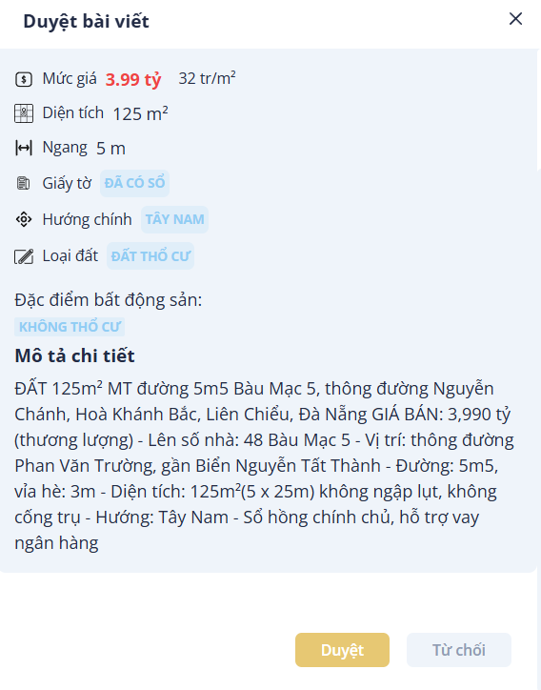

Figure . Post moderation interface

Table . Function specifications for post moderation

|  |  |  |  |
| --- | --- | --- | --- |
| **Interface** | Post moderation | | |
| **Description** | Displays the interface that shows the list of posts requested by the user. | | |
| **Access** | The user selects “Duyệt bài viết” from the user menu in the header. | | |
| Interface Contents | | | |
| **Item** | **Type** | **Description** | |
| Sắp xếp theo | Select | Select sorting criteria for the listings | |
| Chọn trạng thái | Select | Select the status of the post | |
| Pen icon | Button | Open a pop-up to review the post with detailed information | |
| Duyệt | Button | |  | | --- | |  |   Approve the post | |
| Từ chối | Button | Reject the post | |
| **Actions** | | | |
| **Name** | **Description** | **Success** | **Failure** |
| Filter posts | The user selects a filter option or enters a keyword to search for posts | Posts are filtered and displayed accordingly | Show message “Không tìm thấy bất động sản” if no matching property is found |
| Approve/Reject post | The user clicks the “Duyệt” or “Từ chối” button on a post | The post status is updated; approved posts appear in the user's post list | If the update fails, display the message “Cập nhật bài viết thất bại” |
| Select post | The user selects a specific post from the list for review | The post details are loaded for review | Show message “Không tìm thấy bất động sản” if details cannot be loaded |

|  |
| --- |
|  |

* Modify account status

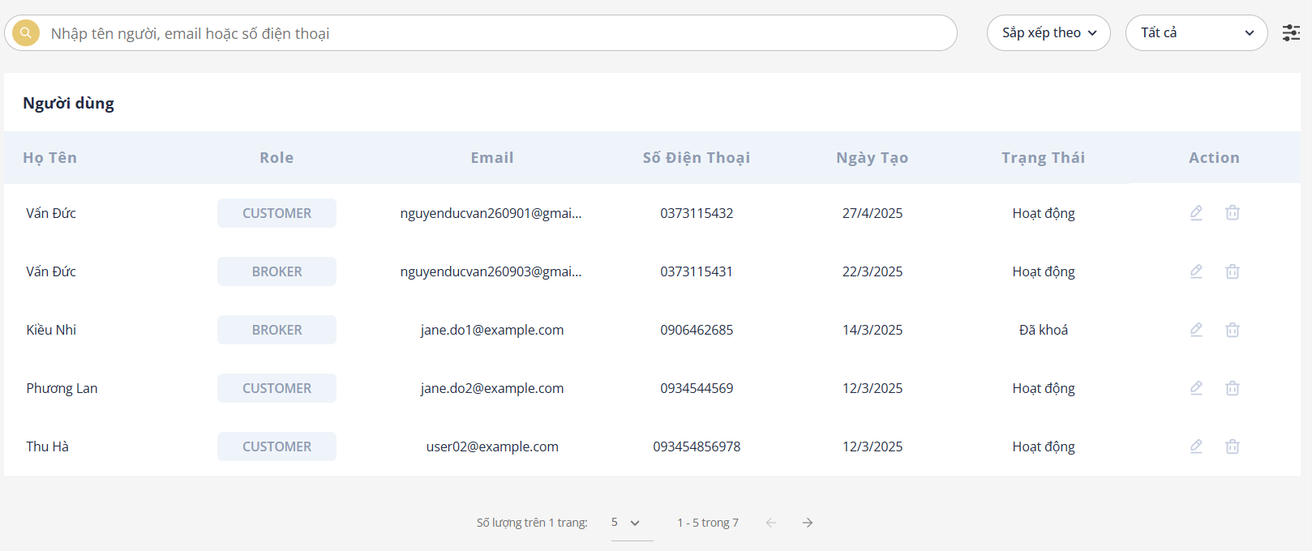

Figure . Account status modification interface

* + Clicks to update user status, a confirmation pop-up like this will be displayed.



Figure . User status change confirmation pop-up

Table . Function specifications for post moderation

|  |  |  |  |
| --- | --- | --- | --- |
| **Interface** | Post moderation | | |
| **Description** | Displays the interface that shows the list of posts requested by the user. | | |
| **Access** | The user selects “Duyệt bài viết” from the user menu in the header. | | |
| Interface Contents | | | |
| **Item** | **Type** | **Description** | |
| Sắp xếp theo | Select | Select sorting criteria for the listings | |
| Chọn trạng thái | Select | Select the status of the user | |
| Pen icon | Button | Open a pop-up to review the post with detailed information | |
| Đồng ý | Button | |  | | --- | |  |   Update user status | |
| **Actions** | | | |
| **Name** | **Description** | **Success** | **Failure** |
| Filter users | The user selects a filter option or enters a keyword to search for posts | Users are filtered and displayed accordingly | Show message “Không tìm thấy người dùng” if no matching user is found |
| Lock/Unlock user | When the confirm button is clicked, the user's status will be updated. | The user's status is updated. A locked user will no longer be able to log in. | If the update fails, display the message “Cập nhật người dùng thất bại” |

## Chapter conclusion

This chapter outlines the key requirements for deploying the website system and describes how the Price support real estate business website operates in practice. It aims to give readers a clearer and more comprehensive understanding of how the system functions in a real-world environment.

# CONCLUSION AND DEVELOPMENT DIRECTION

## Achievements

During the research, theoretical study and system development process, the project has achieved several notable results:

* Theoretical Achievements
  + Gained a solid understanding of web development and applied technologies such as Java, Javascript and Python to build a real estate website with price suggestion support.
  + Understood and implemented the MVC architecture in a real-world application.
  + Acquired the ability to analyze business processes, design system architecture and build a suitable database structure.
  + Learned how to process data, train machine learning models and integrate them into the system to suggest appropriate property prices.
* Practical achievements
  + Successfully built and deployed the Price supports real estate business website, allowing users to search, post and explore property listings along with price reference features.
  + The basic machine learning model was implemented and is capable of providing initial price suggestions to support both buyers and sellers in making informed decisions.
  + Integrated AI functionalities to help moderate content and ensure uploaded images comply with content safety standards.

## Limitations

Despite the accomplishments, there are still several limitations in the current system:

* Login via Facebook and Google has not yet been implemented, which affects the user experience.
* The interface is not yet optimized for mobile devices, which limits accessibility.
* The prediction accuracy of the price suggestion model is still low and needs further improvement in both data quality and algorithm design.
* The UI/UX is not yet professional or user-friendly, requiring further refinement.
* Due to limited time and practical experience, the system analysis was basic and didn’t fully cover all use-case scenarios.
* The system includes only the core features and lacks many important supporting functions, which may impact overall usability and user satisfaction.

## Future development

To improve the system and further enhance the project, the following development directions are proposed:

* Research and apply new technologies to enhance the accuracy of the price prediction model.
* Add Facebook and Google login to improve user convenience.
* Implement features such as comments, ratings and content reporting for better user engagement.
* Integrate Google Maps to visually display the exact location of properties.
* Add statistics and reporting tools for admins, such as view counts, number of listings, average prices by area, etc.
* Develop a chat interface between buyers and sellers to increase direct interaction.
* Improve the user interface with a modern, attractive and responsive design for a better user experience.
* Develop mobile versions of the application on Android/iOS platforms for broader accessibility and convenience.

# REFERENCES

|  |  |
| --- | --- |
| [1] | AWS, "What is Python?," *https://aws.amazon.com/vi/what-is/python/.* |
| [2] | Pum, "Jupyter Notebook là gì? Hướng dẫn cài đặt và sử dụng Jupyter Notebook," *https://200lab.io/blog/jupyter-notebook-la-gi,* 2022. |
| [3] | Jupyter Team, "What is Jupyter?," *https://200lab.io/blog/jupyter-notebook-la-gi,* 2015. |
| [4] | Geeksforgeeks, "Introduction to Java," *https://www.geeksforgeeks.org/introduction-to-java/,* 07 Mar, 2025. |
| [5] | Geeksforgeeks, "Spring Boot Tutorial," *https://www.geeksforgeeks.org/spring-boot/,* 02 Jan, 2025. |
| [6] | T. PM, "Tất tần tật về mô hình MVC," *https://viblo.asia/p/tat-tan-tat-ve-mo-hinh-mvc-Rk74avjAJeO,* 2022. |
| [7] | V. Tong, "Luồng đi trong Spring Boot," *https://viblo.asia/p/luong-di-trong-spring-boot-ORNZqdELK0n,* 2021. |
| [8] | Geeksforgeeks, "What is MySQL?," *https://www.geeksforgeeks.org/what-is-mysql/,* 28 Apr, 2025. |
| [9] | Geeksforgeeks, "React Introduction," *https://www.geeksforgeeks.org/reactjs-introduction/,* 08 Apr, 2025. |
| [10] | H. nội, "What is ReactJS? JavaScript library optimizes for web interface," *https://200lab.io/blog/reactjs-la-gi,* 12 Sep, 2024. |
| [11] | Refine Development, "Introduction to Chakra UI," *https://refine.dev/blog/chakra-ui/,* Sep 17, 2024. |
| [12] | N. Q. Huy, "Tìm hiểu về amazon web service," *https://viblo.asia/p/tim-hieu-ve-amazon-web-service-4dbZN0Vv5YM,* 2017. |
| [13] | ngocvu, "Tìm hiểu S3 - AWS," *https://viblo.asia/p/tim-hieu-s3-aws-amazon-simple-storage-service-gDVK2QGm5Lj,* 2018. |
| [14] | AWS, "Amazon Relational Database Service," *https://aws.amazon.com/vi/rds/,* 2024. |
| [15] | Vercel, "What does Vercel do?," *https://vercel.com/blog/what-is-vercel,* May 10, 2023. |
| [16] | B. Christian, "NudeNet: Neural Nets for Nudity Classification, Detection and selective censoring," *https://gitlab.com/christianbrinkmann/nudenetv2,* Sep 2024. |
| [17] | T. Nguyễn, *https://huggingface.co/naot97/vietnamese-toxicity-detection_1/tree/main,* May 2024. |

# APPENDIX 1

# APPENDIX 2